Triangle Congruence

Definition
# Source: AI Source: Provided by: [Data Path: Persons Table -> ID Column: 1, Name_En Column: Motasem Essam] -> From: [ChatGPT] on [7/25/2026]
Triangle Congruence is a geometric relationship in which two triangles have exactly the same shape and the same size.
Two triangles are congruent if one triangle can be moved using translation, rotation, and/or reflection so that it exactly matches the other triangle.
The symbol for congruence is:
$$\boxed{≅}$$
Therefore:
$$\boxed{△ABC≅△DEF}$$
means that triangle $ABC$is congruent to triangle $DEF$.
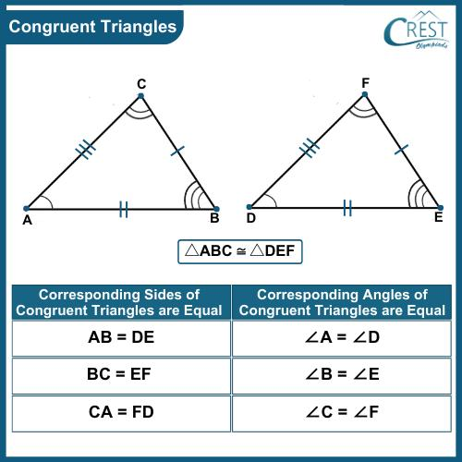
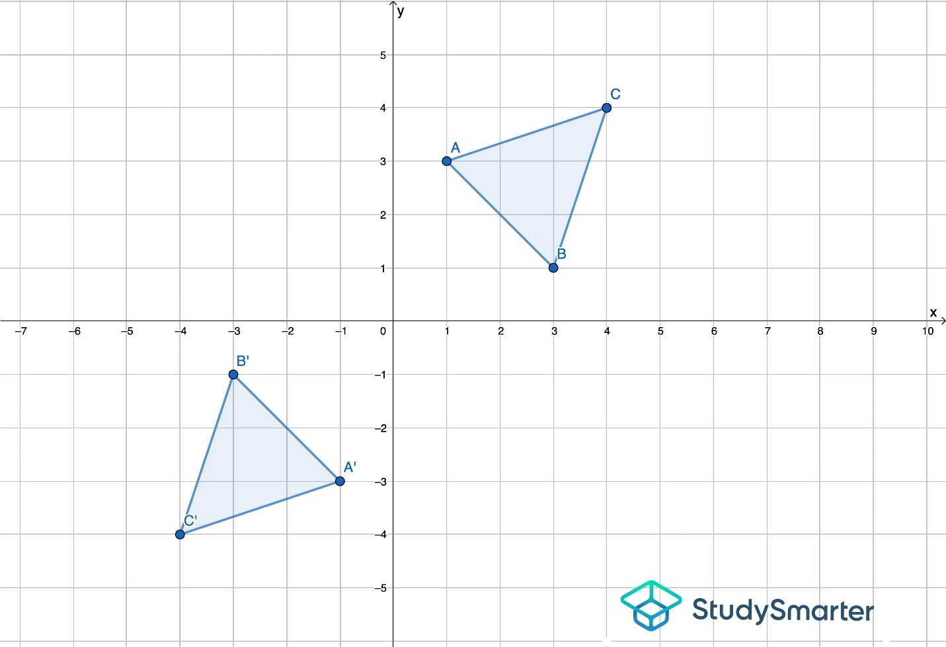
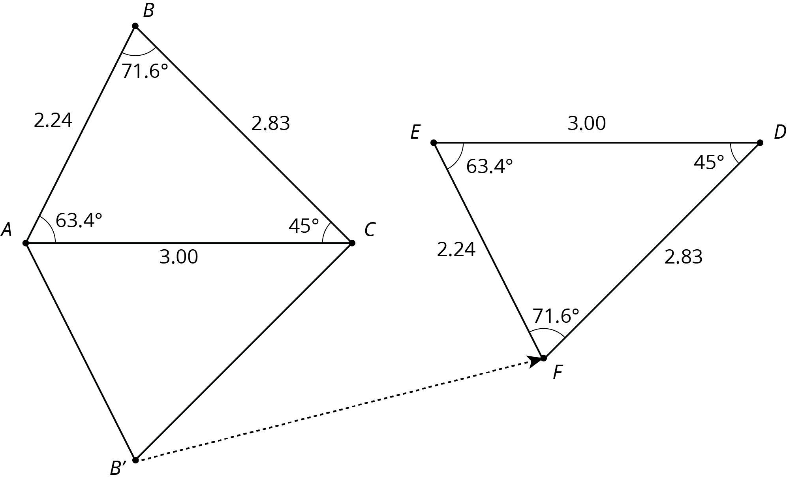
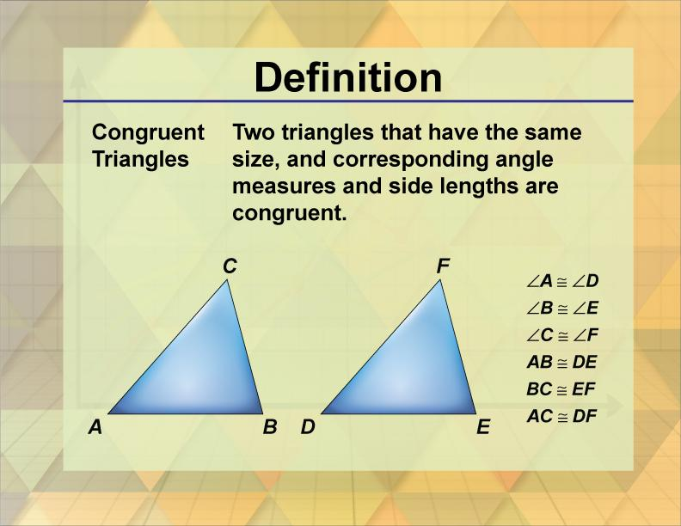
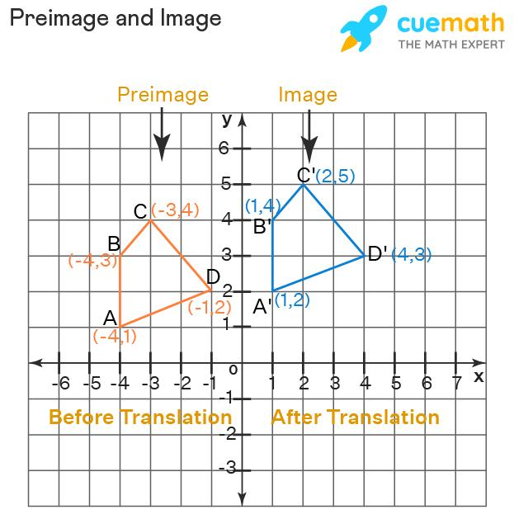

Purpose
# Source: AI Source: Provided by: [Data Path: Persons Table -> ID Column: 1, Name_En Column: Motasem Essam] -> From: [ChatGPT] on [7/25/2026]
Triangle congruence is used to:
- Determine whether two triangles are identical in size and shape.
- Prove that corresponding sides are equal.
- Prove that corresponding angles are equal.
- Solve unknown side lengths.
- Solve unknown angle measures.
- Prove geometric relationships.
- Analyze geometric constructions.
- Support engineering and architectural designs.

Fundamental Idea
# Source: AI Source: Provided by: [Data Path: Persons Table -> ID Column: 1, Name_En Column: Motasem Essam] -> From: [ChatGPT] on [7/25/2026]
Two triangles are congruent when all corresponding sides and corresponding angles have equal measures.
If:
$$△ABC≅△DEF$$
then the correspondence is:
$$\boxed{A↔D} \\ \boxed{B↔E} \\ \boxed{C↔F}$$
Therefore:
$$\boxed{AB=DE} \\ \boxed{BC=EF} \\ \boxed{AC=DF}$$
and:
$$\boxed{∠A=∠D} \\ \boxed{∠B=∠E} \\ \boxed{∠C=∠F}$$

Corresponding Parts
# Source: AI Source: Provided by: [Data Path: Persons Table -> ID Column: 1, Name_En Column: Motasem Essam] -> From: [ChatGPT] on [7/25/2026]
Corresponding parts are parts that occupy the same relative positions in two congruent triangles.
Corresponding Vertices
$$A↔D \\ B↔E \\ C↔F$$
Corresponding Sides
$$AB↔DE \\ BC↔EF \\ AC↔DF$$
Corresponding Angles
$$∠A↔∠D \\ ∠B↔∠E \\ ∠C↔∠F$$
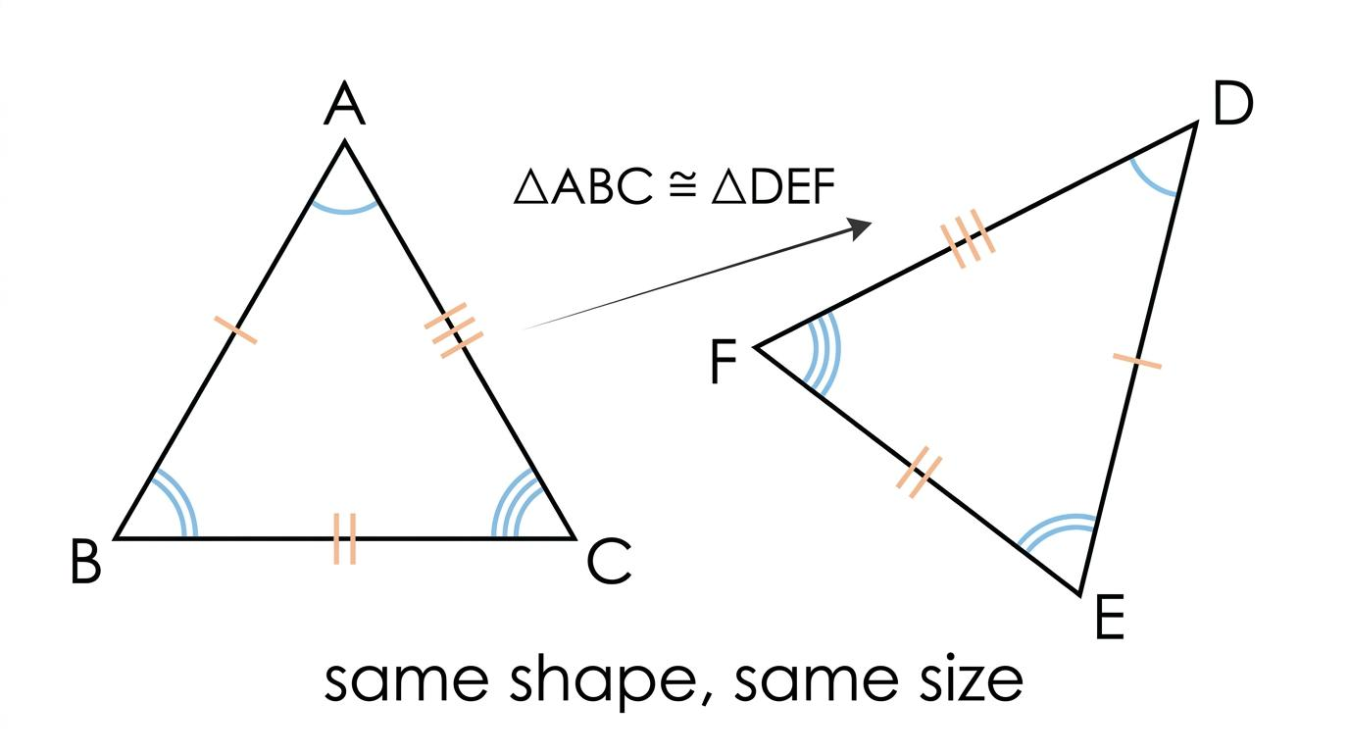
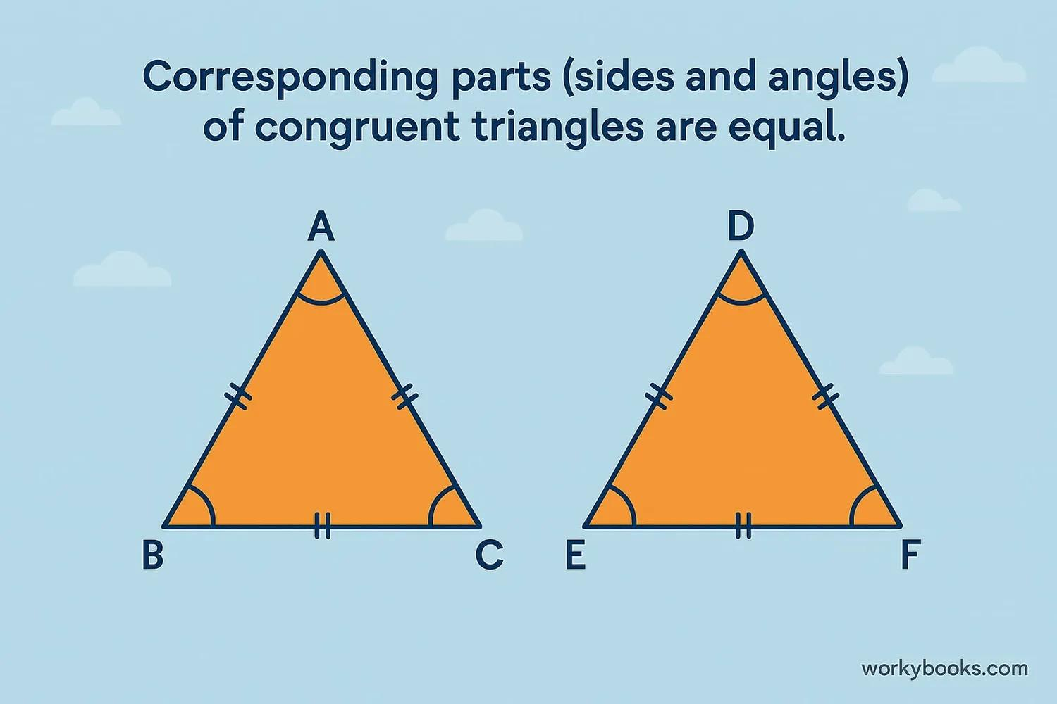
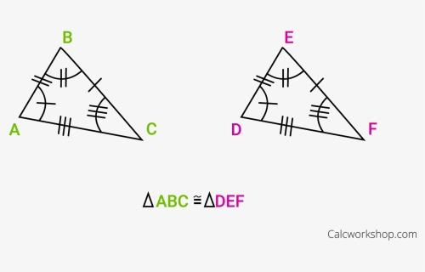
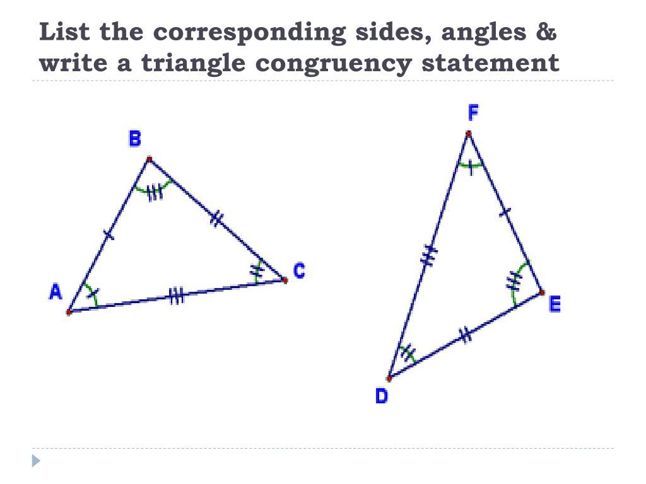

Congruence Symbol
# Source: AI Source: Provided by: [Data Path: Persons Table -> ID Column: 1, Name_En Column: Motasem Essam] -> From: [ChatGPT] on [7/25/2026]
The symbol:
$$\boxed{≅}$$
means is congruent to.
For example:
$$\boxed{△ABC≅△DEF}$$
This is different from:
$$=$$
which means equality.

Congruence vs Equality
# Source: AI Source: Provided by: [Data Path: Persons Table -> ID Column: 1, Name_En Column: Motasem Essam] -> From: [ChatGPT] on [7/25/2026]
Equality usually compares values:
$$AB=DE$$
Congruence compares geometric figures:
$$△ABC≅△DEF$$
Thus:
$$\boxed{=\text{ compares values}} \\ \boxed{≅\text{ compares geometric figures}}$$

Conditions for Triangle Congruence
# Source: AI Source: Provided by: [Data Path: Persons Table -> ID Column: 1, Name_En Column: Motasem Essam] -> From: [ChatGPT] on [7/25/2026]
There are several standard criteria for proving that two triangles are congruent.
The main criteria are:
- SSS
- SAS
- ASA
- AAS
- RHS / HL

1. SSS — Side-Side-Side
# Source: AI Source: Provided by: [Data Path: Persons Table -> ID Column: 1, Name_En Column: Motasem Essam] -> From: [ChatGPT] on [7/25/2026]
SSS means Side-Side-Side.
If all three corresponding sides of two triangles are equal, the triangles are congruent.
If:
$$AB=DE \\ BC=EF \\ AC=DF$$
then:
$$\boxed{△ABC≅△DEF}$$
by SSS.
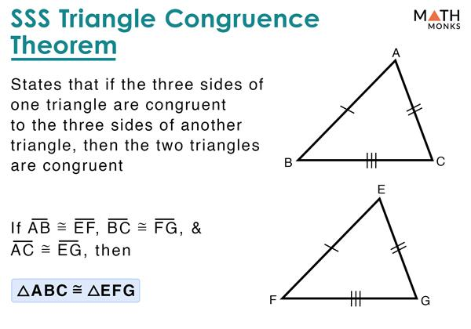
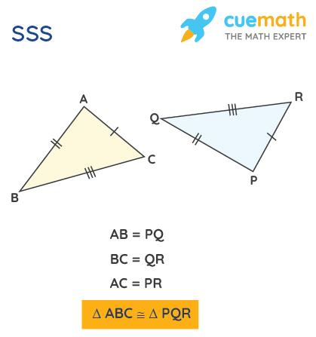
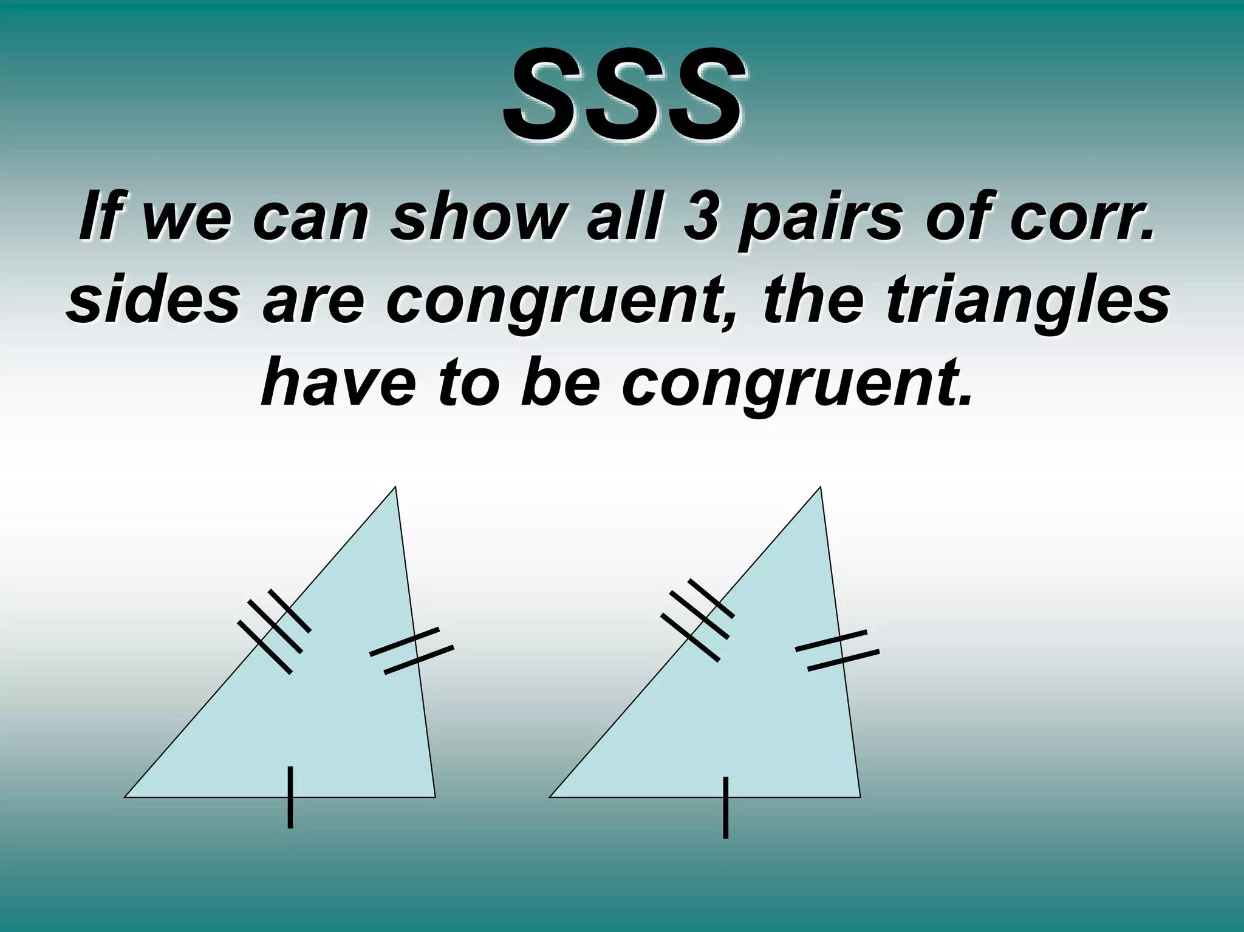
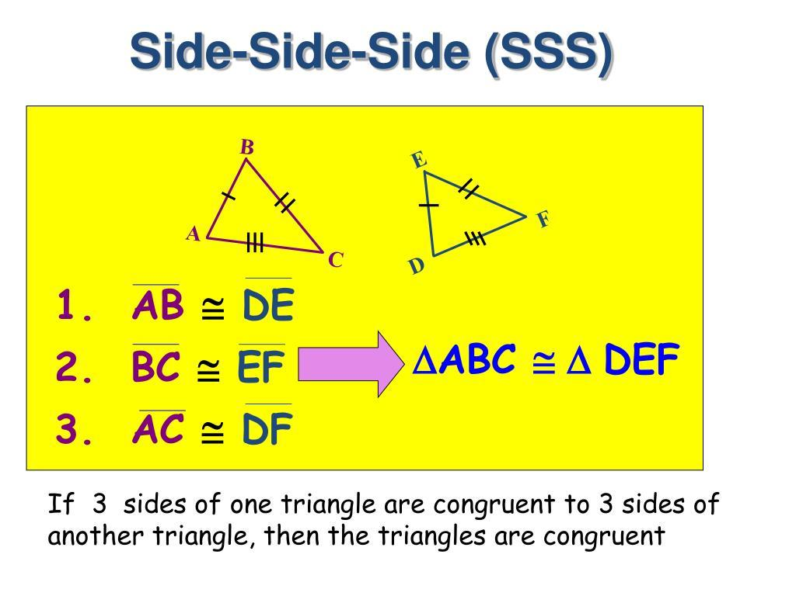
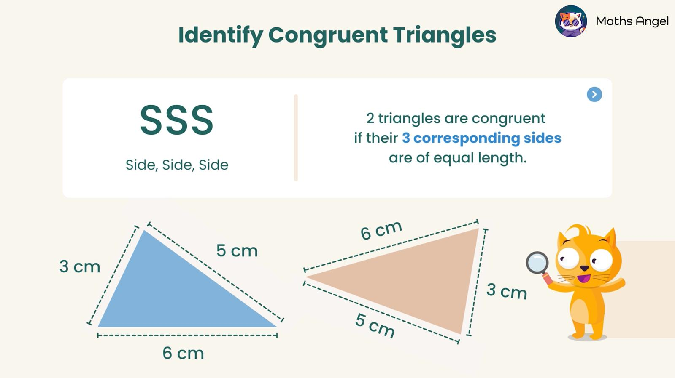
Example
Triangle 1:
$$3, 4, 5$$
Triangle 2:
$$3, 4, 5$$
Since all three corresponding sides are equal:
$$\boxed{△_{1}≅△_{2}}$$
by SSS.

2. SAS — Side-Angle-Side
# Source: AI Source: Provided by: [Data Path: Persons Table -> ID Column: 1, Name_En Column: Motasem Essam] -> From: [ChatGPT] on [7/25/2026]
SAS means Side-Angle-Side.
Two triangles are congruent if:
- Two corresponding sides are equal.
- The included angle between those sides is equal.
For example:
$$AB=DE \\ BC=EF$$
and:
$$∠B=∠E$$
then:
$$\boxed{△ABC≅△DEF}$$
by SAS.
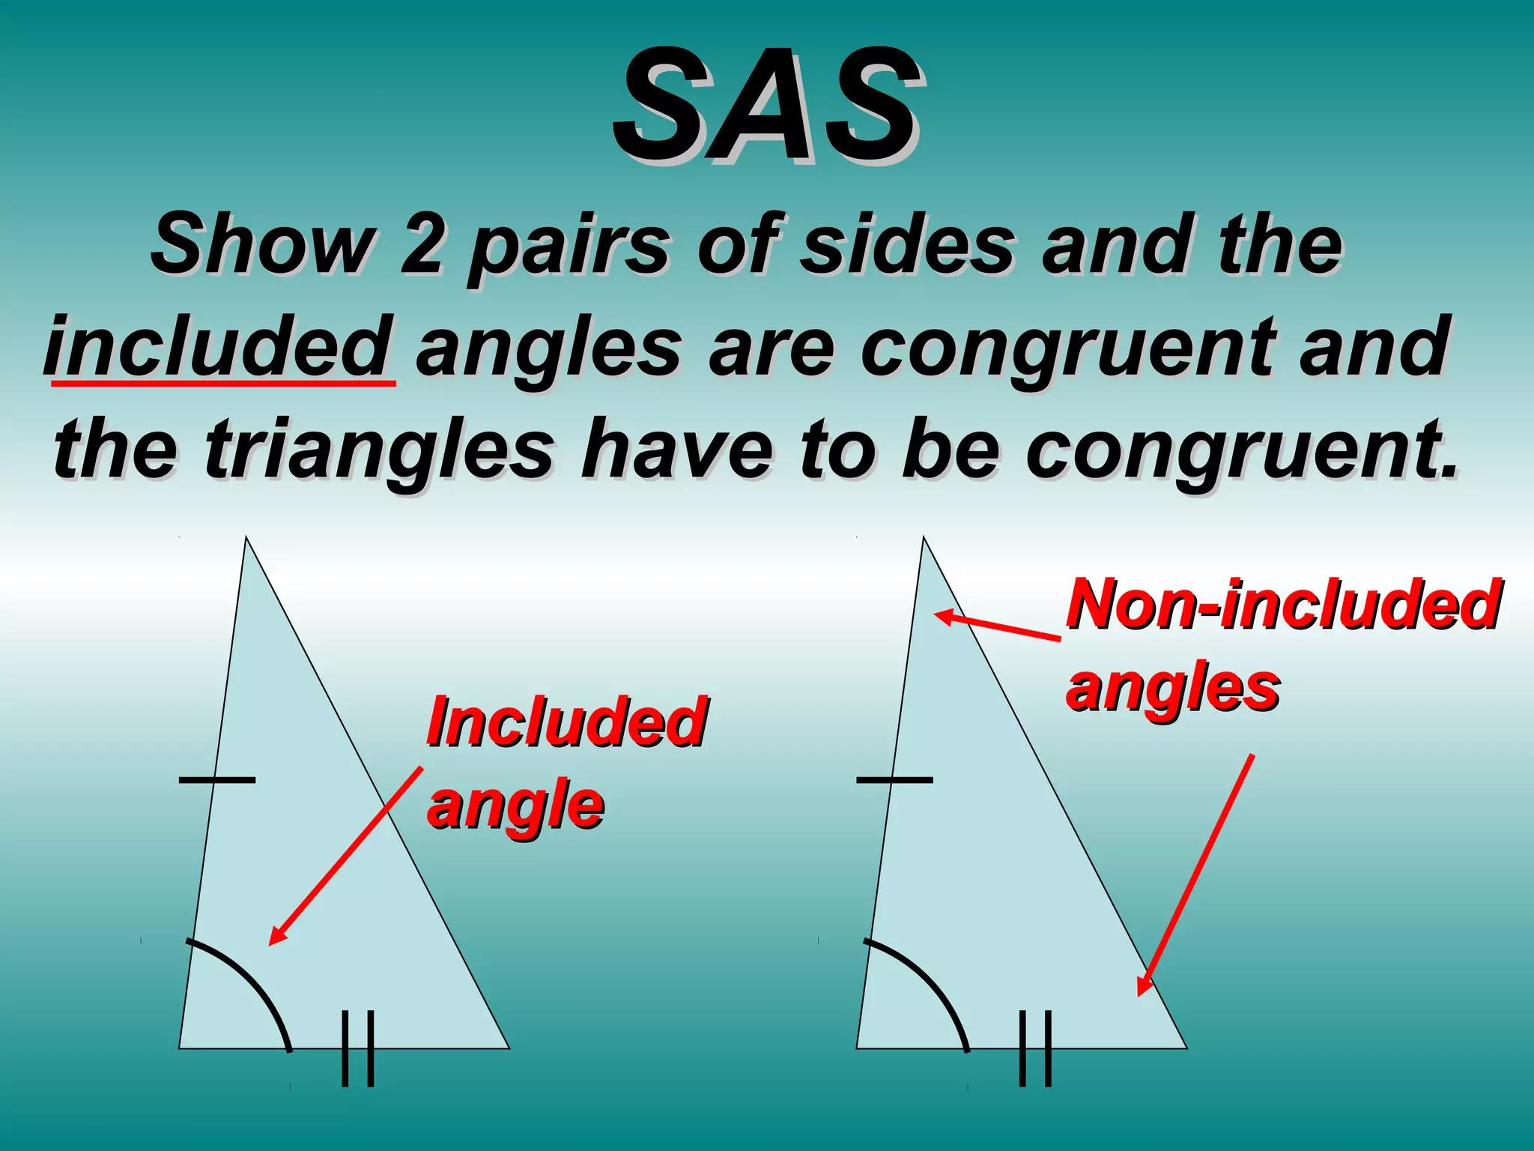
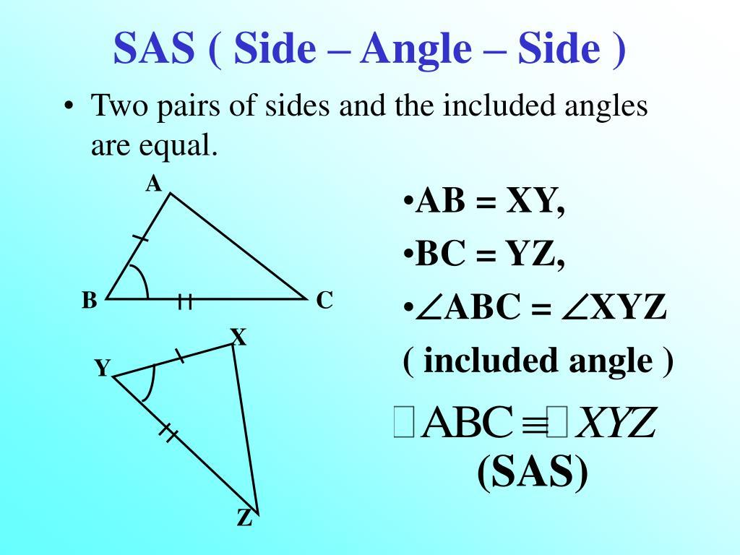
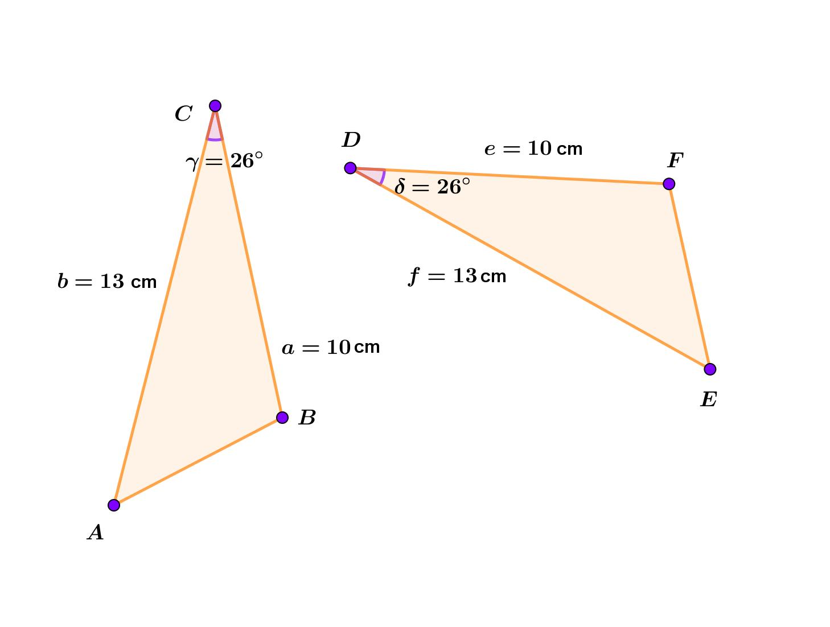
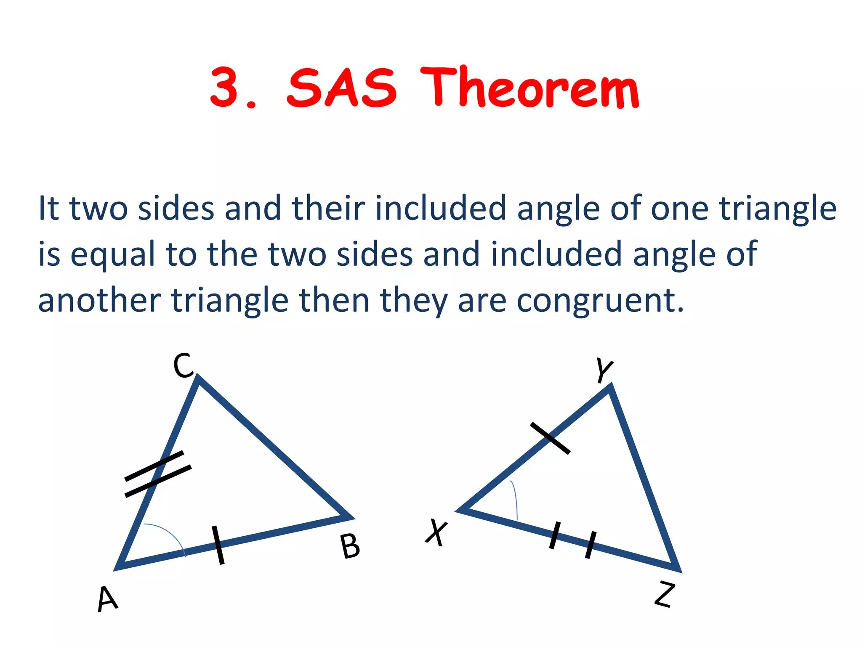
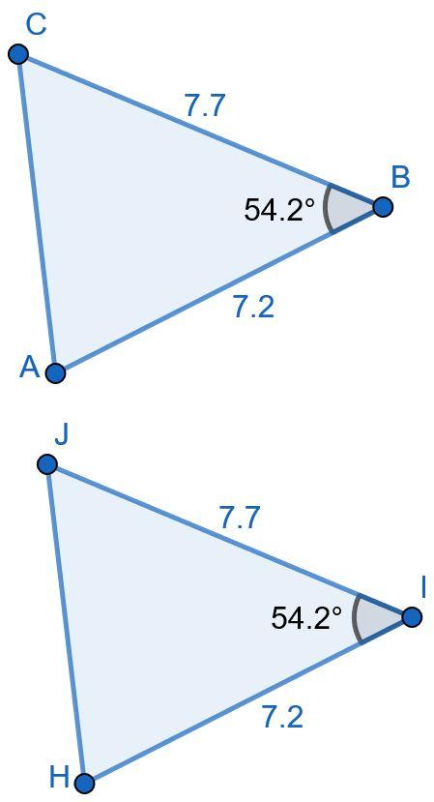
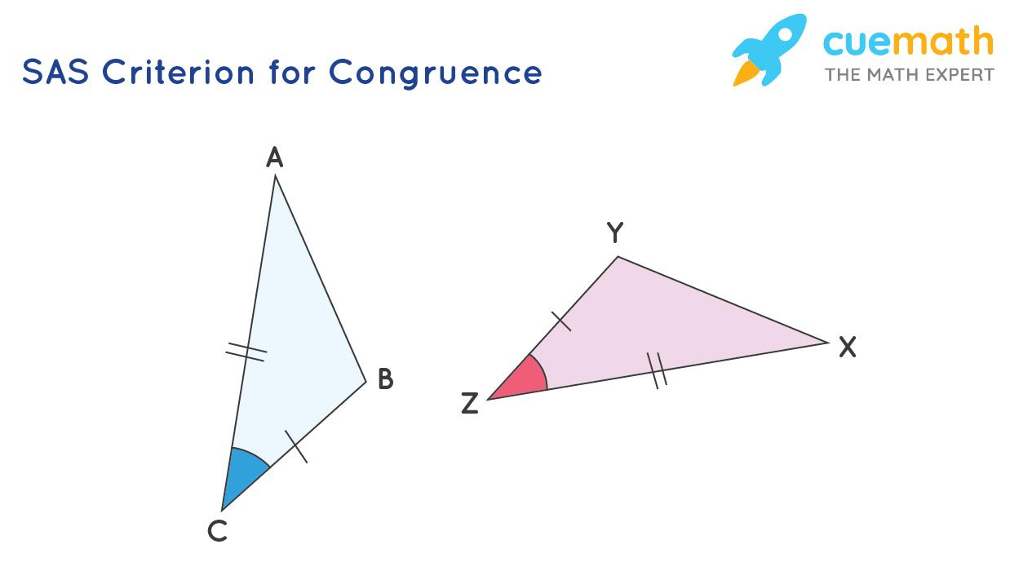
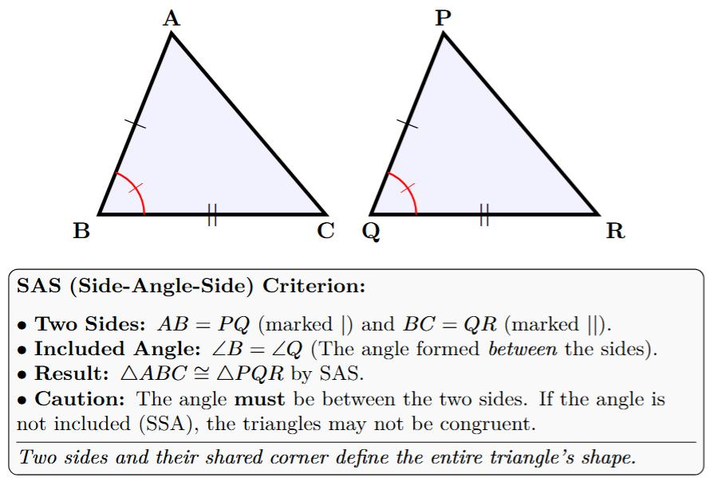
Important
The angle must be the included angle between the two known sides.

3. ASA — Angle-Side-Angle
# Source: AI Source: Provided by: [Data Path: Persons Table -> ID Column: 1, Name_En Column: Motasem Essam] -> From: [ChatGPT] on [7/25/2026]
ASA means Angle-Side-Angle.
Two triangles are congruent if:
- Two corresponding angles are equal.
- The included side between those angles is equal.
For example:
$$∠A=∠D \\ AB=DE \\ ∠B=∠E$$
Therefore:
$$\boxed{△ABC≅△DEF}$$
by ASA.
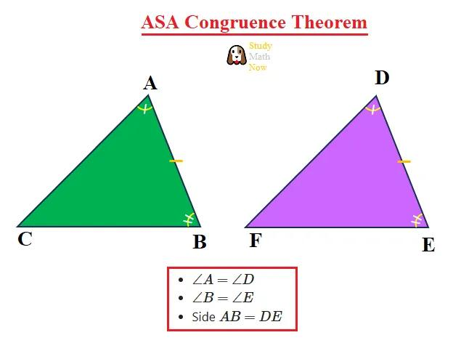
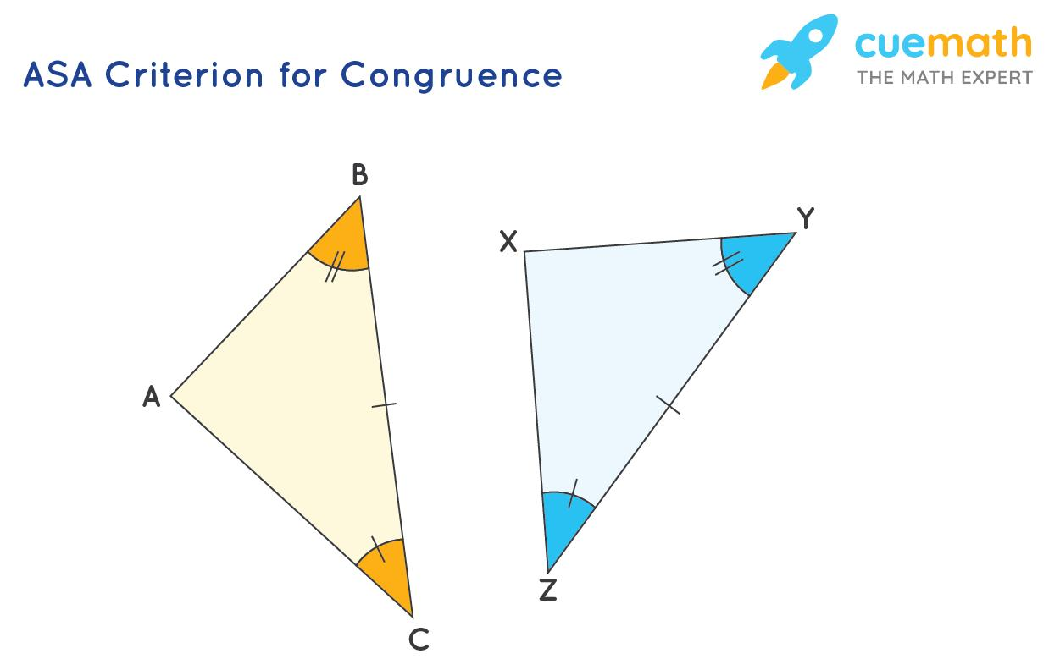
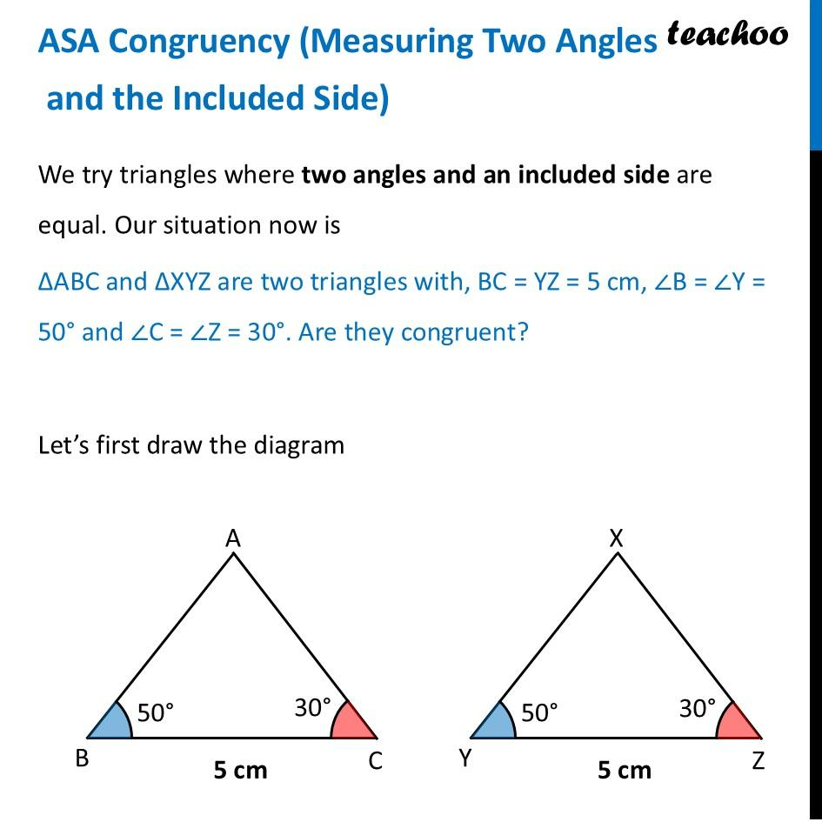
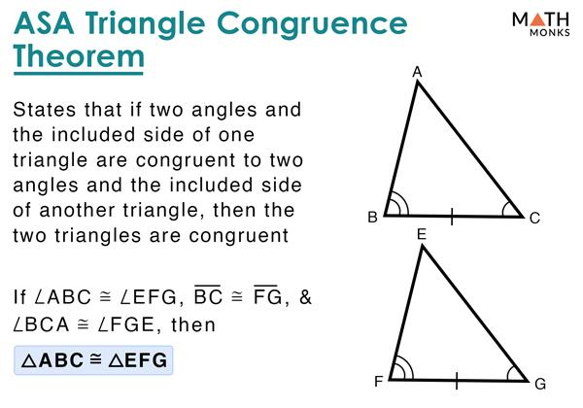

4. AAS — Angle-Angle-Side
# Source: AI Source: Provided by: [Data Path: Persons Table -> ID Column: 1, Name_En Column: Motasem Essam] -> From: [ChatGPT] on [7/25/2026]
AAS means Angle-Angle-Side.
Two triangles are congruent if:
- Two corresponding angles are equal.
- A corresponding side that is not between the two angles is equal.
For example:
$$∠A=∠D \\ ∠B=∠E$$
and:
$$AC=DF$$
Therefore:
$$\boxed{△ABC≅△DEF}$$
by AAS.
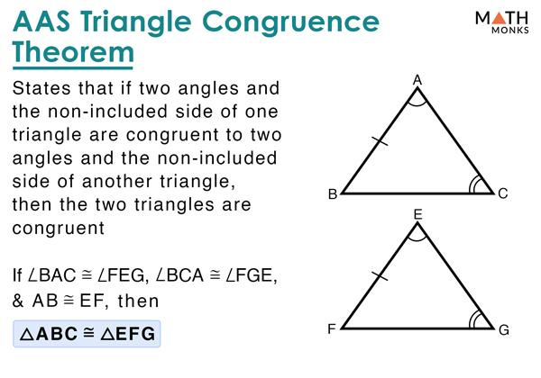
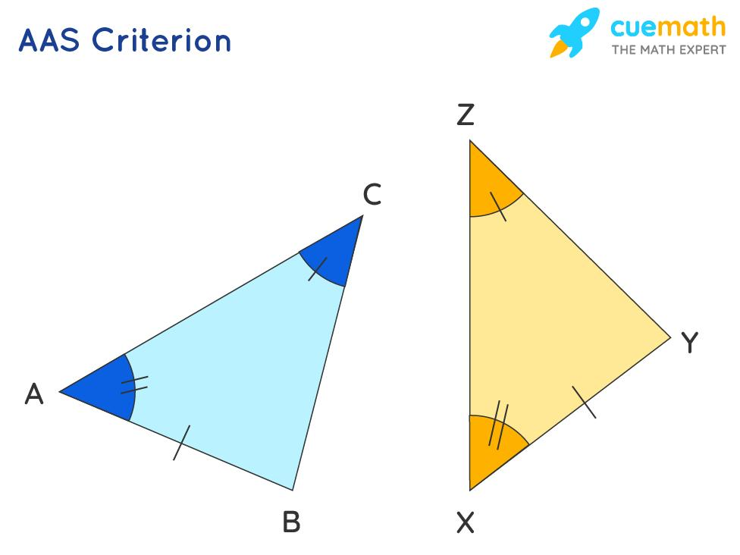
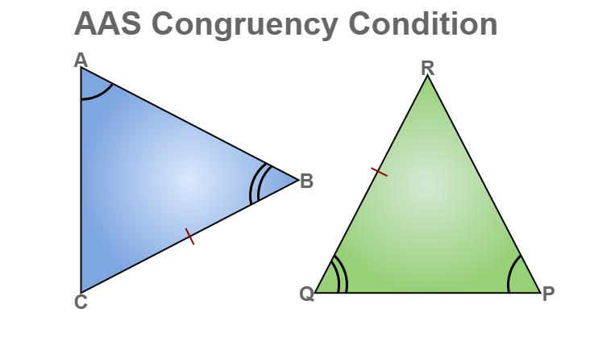
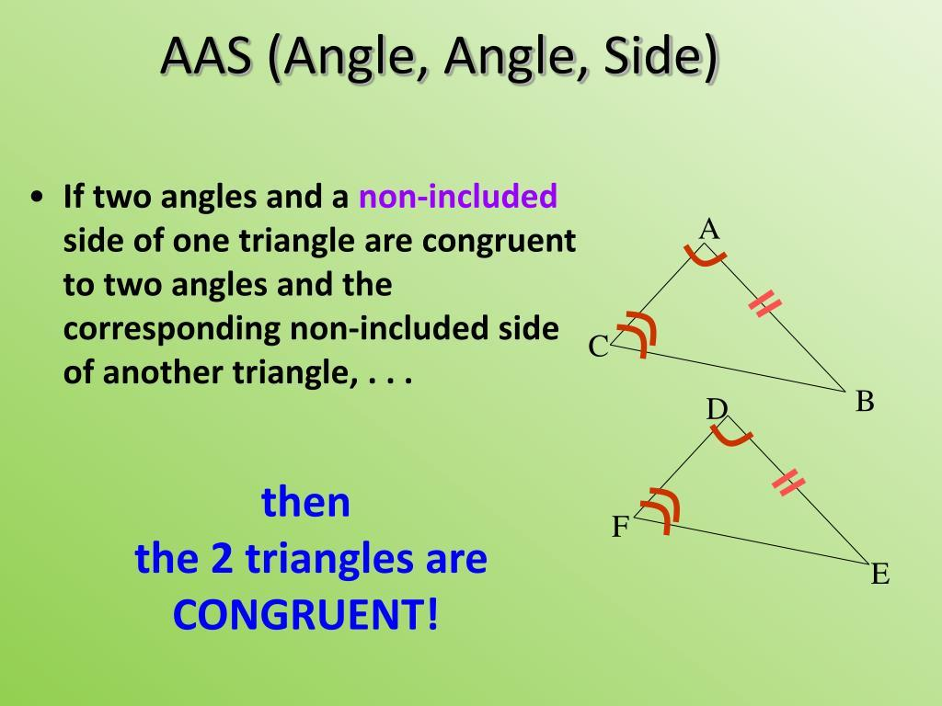
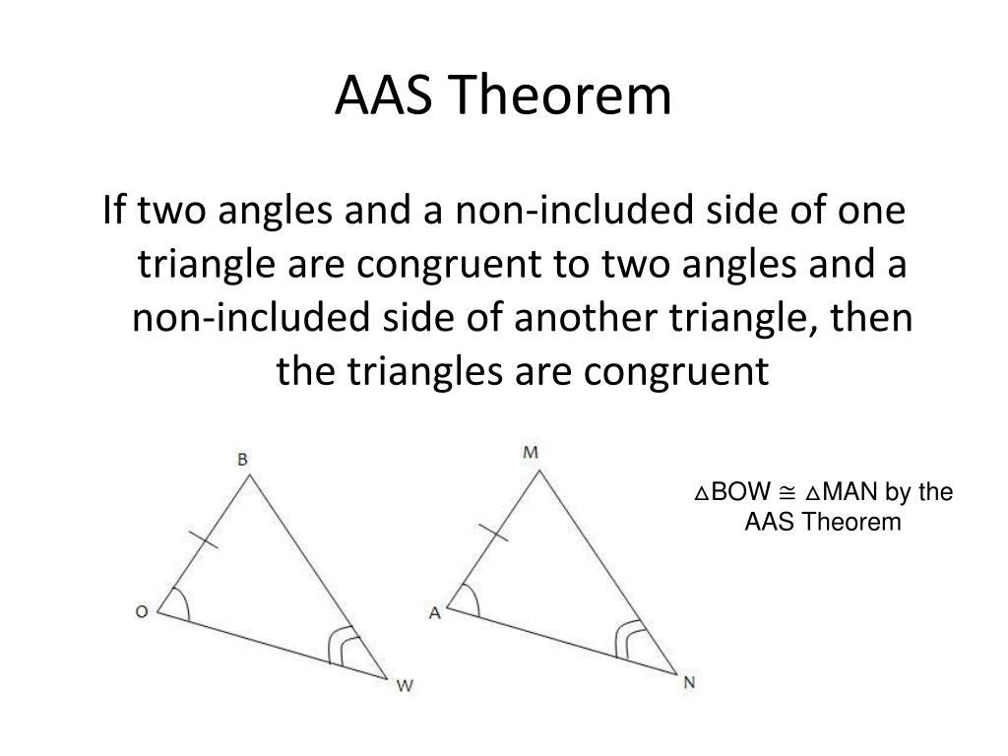

5. RHS / HL — Right Angle-Hypotenuse-Side
# Source: AI Source: Provided by: [Data Path: Persons Table -> ID Column: 1, Name_En Column: Motasem Essam] -> From: [ChatGPT] on [7/25/2026]
For right triangles, a special congruence criterion is commonly called:
- RHS — Right angle-Hypotenuse-Side
- HL — Hypotenuse-Leg
Two right triangles are congruent if:
- Both have a right angle.
- Their hypotenuses are equal.
- One corresponding leg is equal.
For example:
$$∠B=∠E={90}^{∘} \\ AC=DF$$
and:
$$AB=DE$$
Therefore:
$$\boxed{△ABC≅△DEF}$$
by RHS/HL.
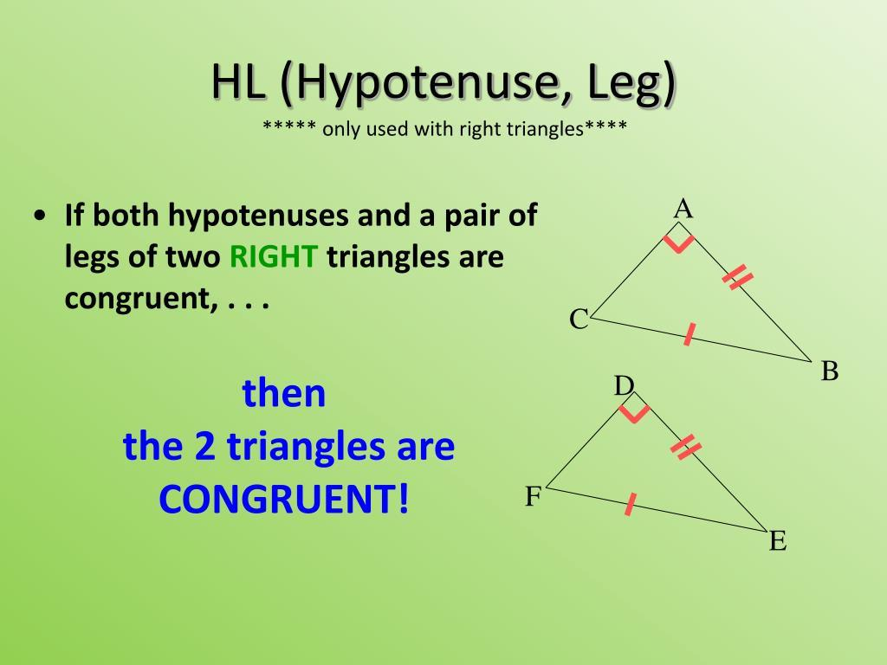
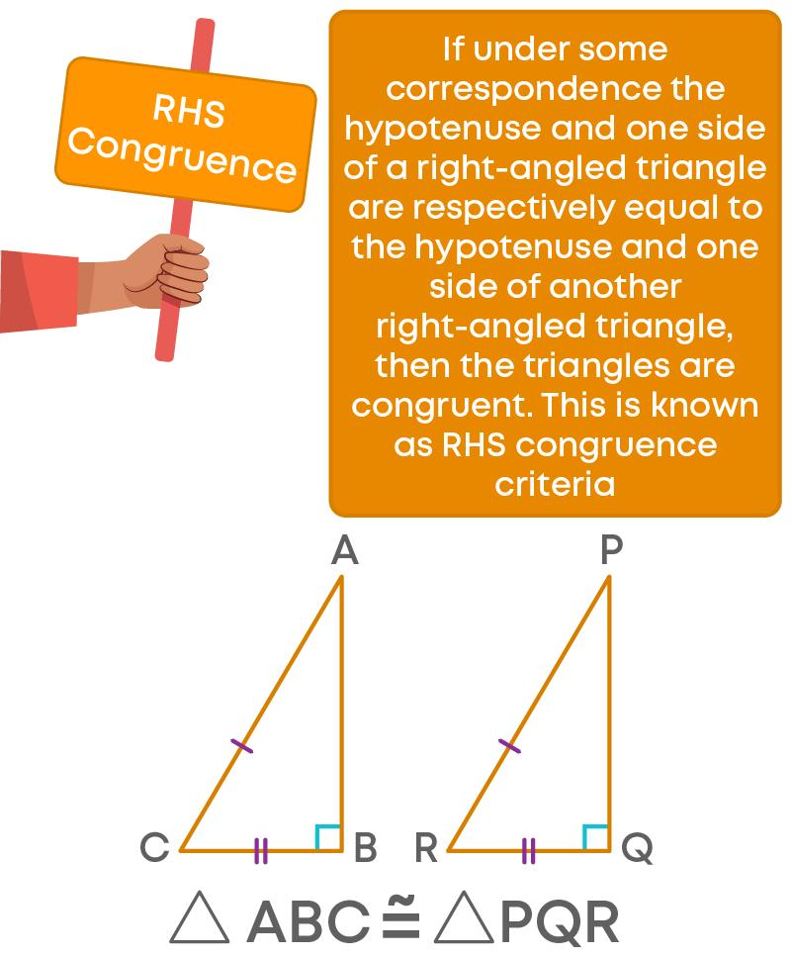
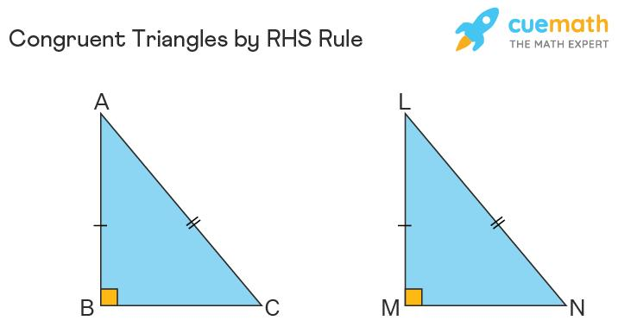
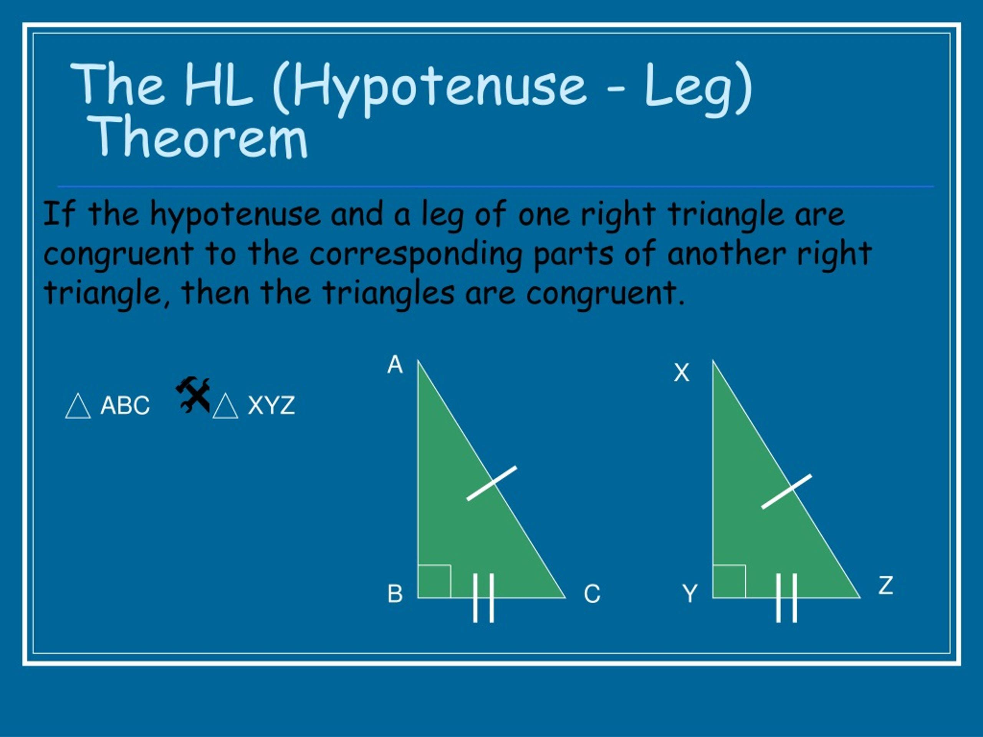
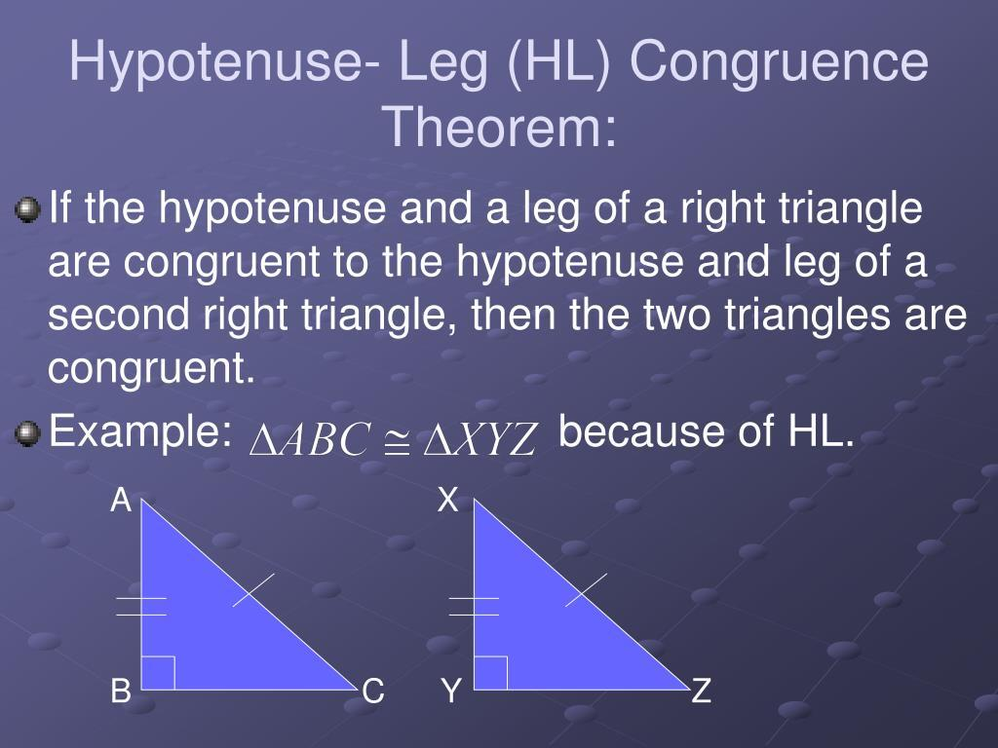
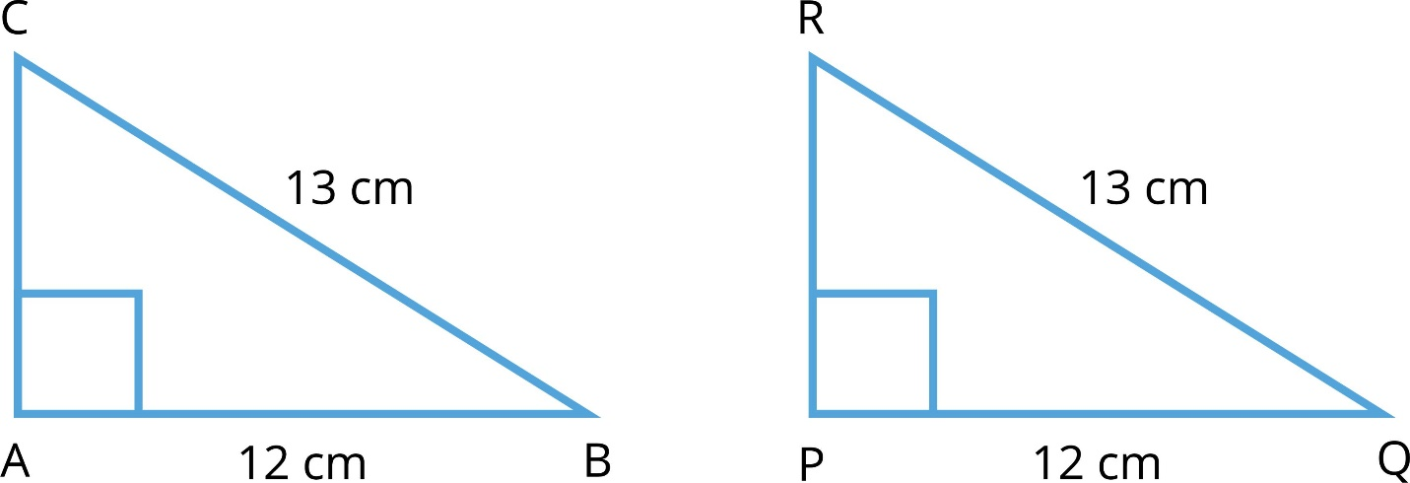

Congruence Criteria Summary
# Source: AI Source: Provided by: [Data Path: Persons Table -> ID Column: 1, Name_En Column: Motasem Essam] -> From: [ChatGPT] on [7/25/2026]
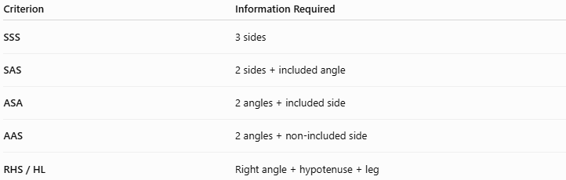
Criterion | Information Required
SSS | 3 sides
SAS | 2 sides + included angle
ASA | 2 angles + included side
AAS | 2 angles + non-included side
RHS / HL | Right angle + hypotenuse + leg

AAA Is Not a Congruence Criterion
# Source: AI Source: Provided by: [Data Path: Persons Table -> ID Column: 1, Name_En Column: Motasem Essam] -> From: [ChatGPT] on [7/25/2026]
AAA means:
$$\boxed{\text{Angle-Angle-Angle}}$$
Knowing all three angles are equal does not prove congruence.
Why?
Because triangles can have the same angles but different sizes.
For example:
$${60}^{∘}, {60}^{∘}, {60}^{∘}$$
describes an equilateral triangle, but the triangles could have side lengths:
$$2, 2, 2$$
or:
$$5, 5, 5$$
They have the same shape but different sizes.
Therefore:
$$\boxed{\text{AAA proves similarity, not congruence}}$$
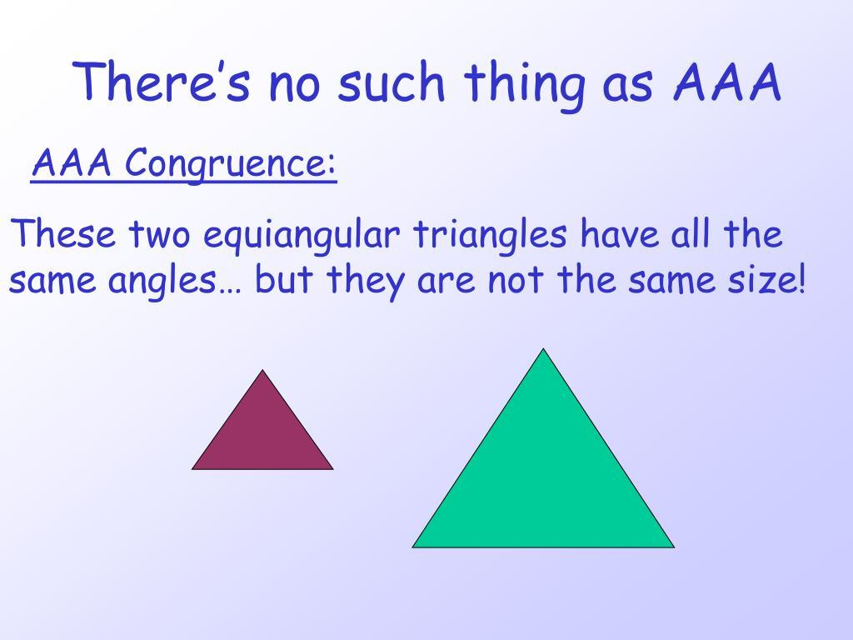
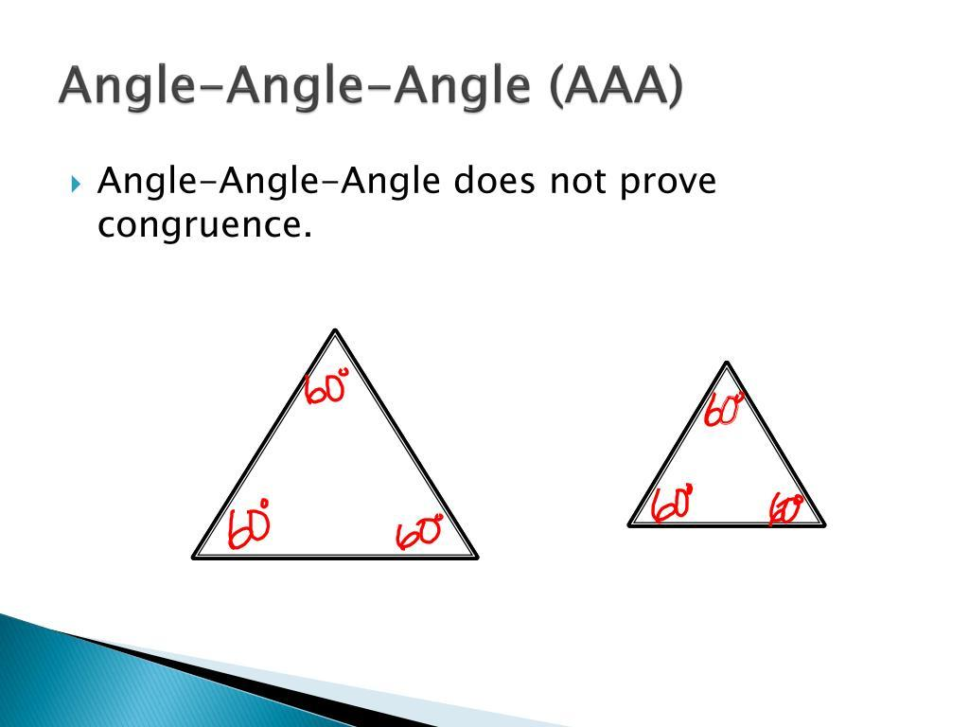
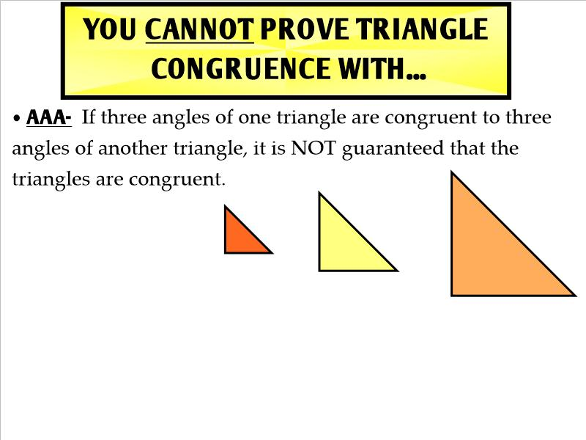
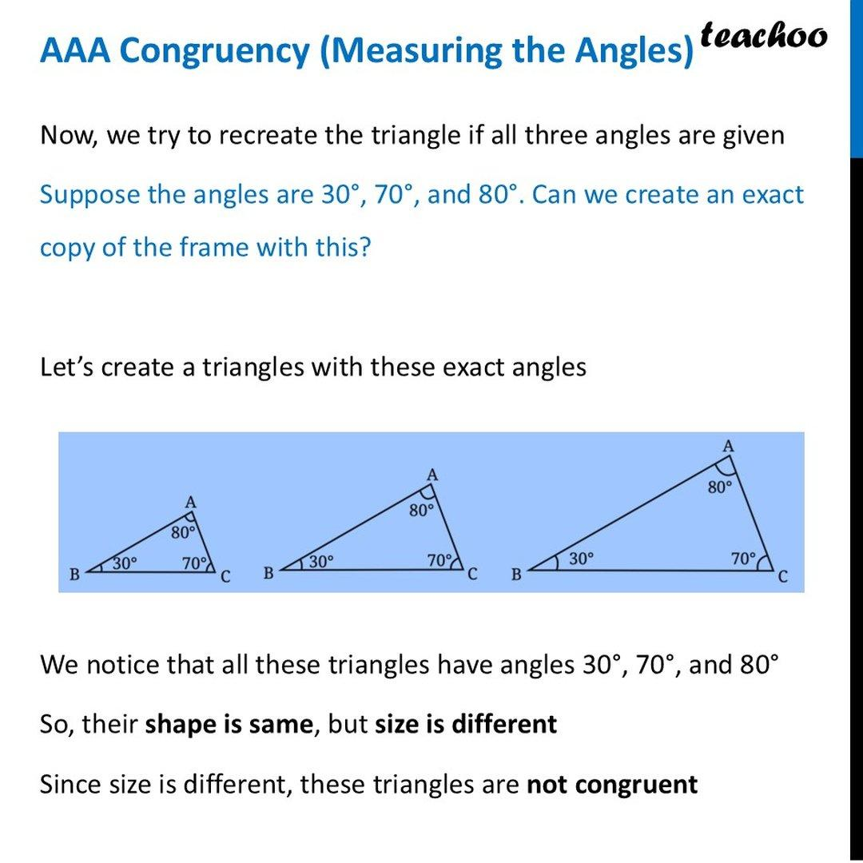
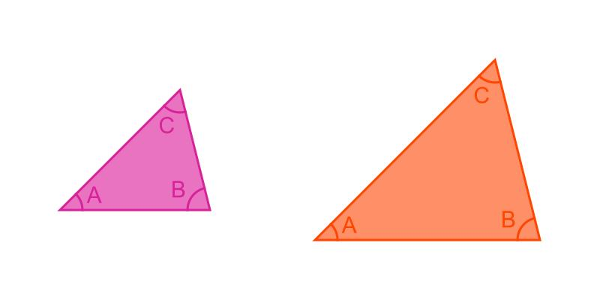

SSA Is Generally Not a Congruence Criterion
# Source: AI Source: Provided by: [Data Path: Persons Table -> ID Column: 1, Name_En Column: Motasem Essam] -> From: [ChatGPT] on [7/25/2026]
SSA means:
$$\boxed{\text{Side-Side-Angle}}$$
In general, SSA does not guarantee triangle congruence.
It can produce two different triangles with the same given information. This is known as the ambiguous case.
Therefore:
$$\boxed{\text{SSA is generally not a valid congruence criterion}}$$
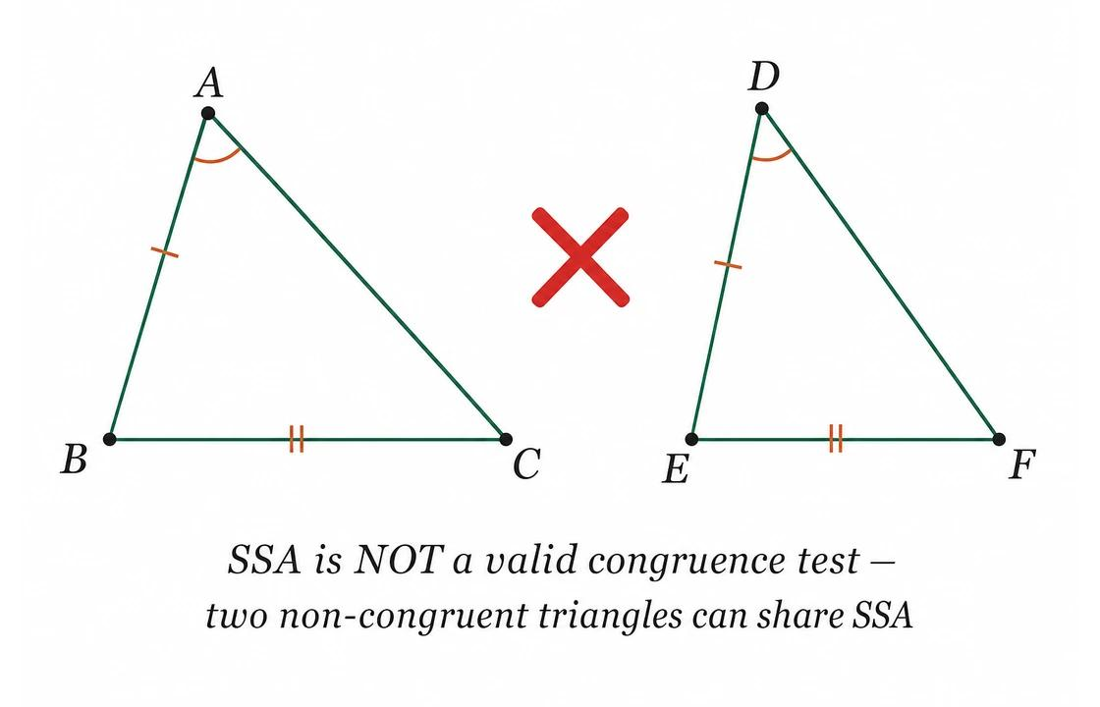
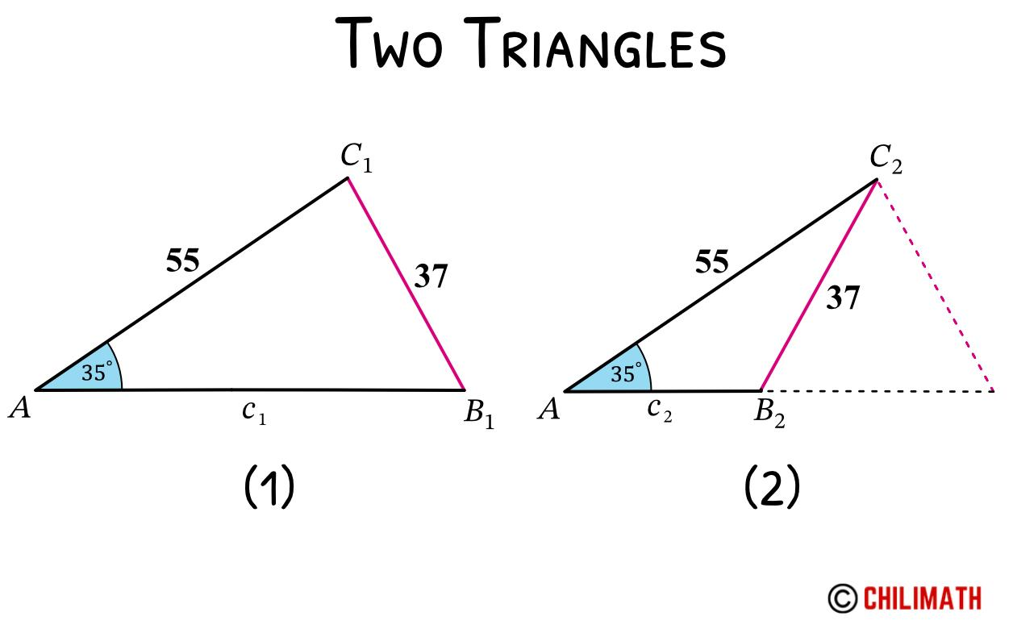
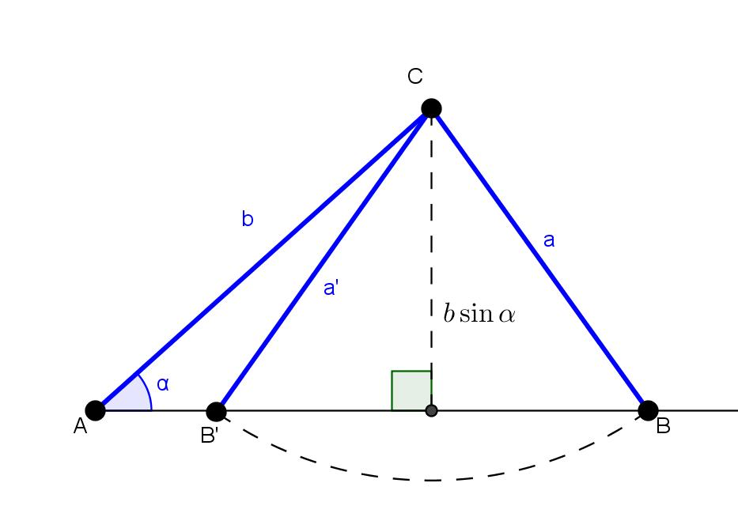
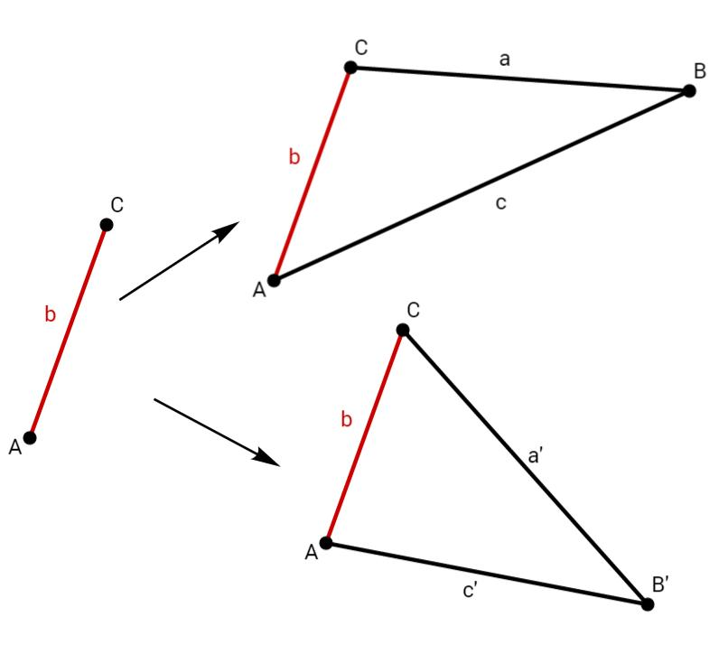
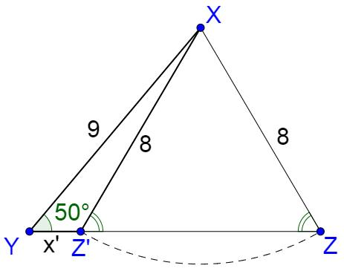
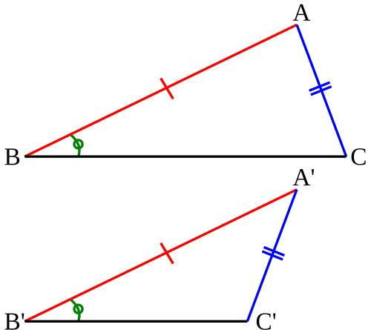

Congruence Through Transformations
# Source: AI Source: Provided by: [Data Path: Persons Table -> ID Column: 1, Name_En Column: Motasem Essam] -> From: [ChatGPT] on [7/25/2026]
Two figures are congruent if one can be transformed into the other using rigid transformations.
These include:
Translation
$$\boxed{\left(x, y\right)→\left(x +a,y+b\right)}$$
Rotation
Turns the figure around a fixed point.
Reflection
Flips the figure across a line.
These transformations preserve:
- Length
- Angle
- Shape
- Area
Therefore, they preserve congruence.
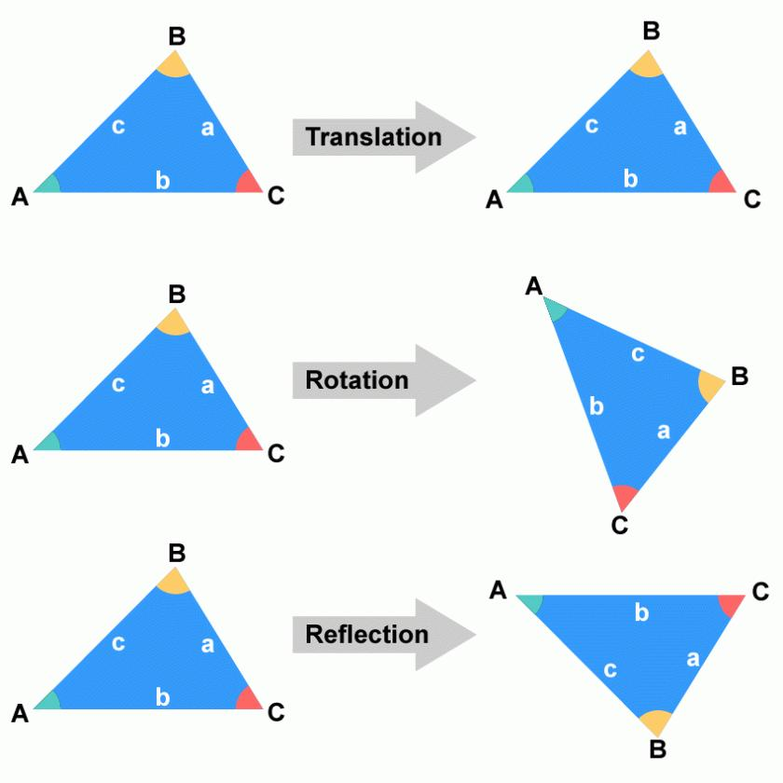
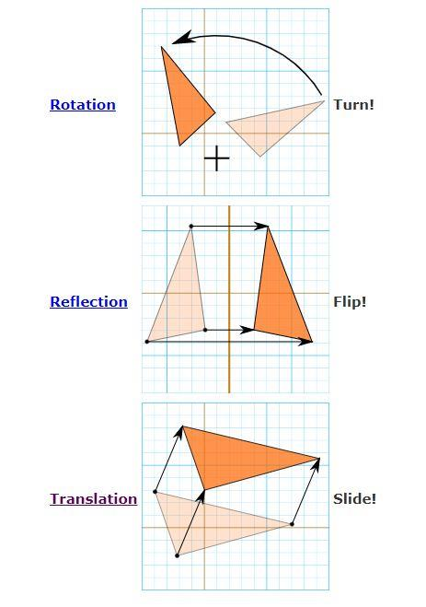
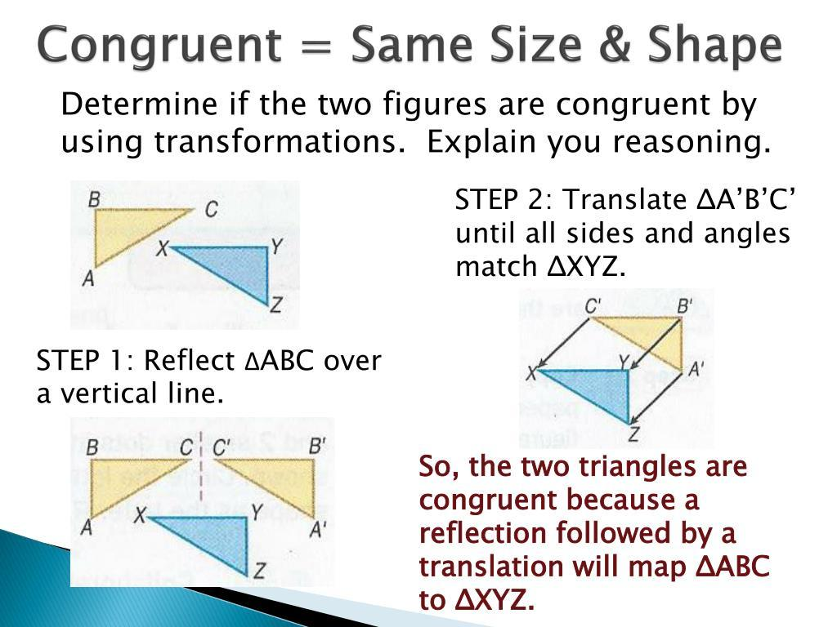
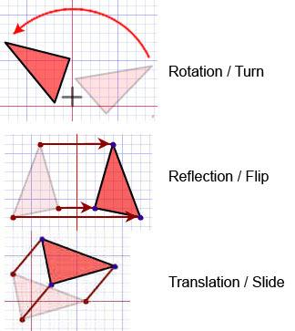

Dilation and Congruence
# Source: AI Source: Provided by: [Data Path: Persons Table -> ID Column: 1, Name_En Column: Motasem Essam] -> From: [ChatGPT] on [7/25/2026]
Dilation is generally not a congruence transformation because it changes the size of a figure.
For example:
$$△ABC$$
can become a larger triangle:
$$△A^{'}B^{'}C^{'}$$
with:
$$AB≠A^{'}B^{'}$$
Therefore:
$$\boxed{\text{Dilation generally preserves similarity, not congruence}}$$

Shear and Congruence
# Source: AI Source: Provided by: [Data Path: Persons Table -> ID Column: 1, Name_En Column: Motasem Essam] -> From: [ChatGPT] on [7/25/2026]
A shear generally changes:
- Angles
- Side lengths
- Shape
Therefore:
$$\boxed{\text{Shear does not generally preserve congruence}}$$

Congruence and Area
# Source: AI Source: Provided by: [Data Path: Persons Table -> ID Column: 1, Name_En Column: Motasem Essam] -> From: [ChatGPT] on [7/25/2026]
Congruent triangles have equal areas.
If:
$$△ABC≅△DEF$$
then:
$$\boxed{\left[△ABC\right]=\left[△DEF\right]}$$

Congruence and Perimeter
# Source: AI Source: Provided by: [Data Path: Persons Table -> ID Column: 1, Name_En Column: Motasem Essam] -> From: [ChatGPT] on [7/25/2026]
Congruent triangles have equal corresponding side lengths.
Therefore, their perimeters are equal:
$$\boxed{P_{1}=P_{2}}$$
If:
$$a+b+c$$
is the perimeter of the first triangle, then the congruent triangle has the same perimeter.

Congruence and Angles
# Source: AI Source: Provided by: [Data Path: Persons Table -> ID Column: 1, Name_En Column: Motasem Essam] -> From: [ChatGPT] on [7/25/2026]
Corresponding angles of congruent triangles are equal.
If:
$$△ABC≅△DEF$$
then:
$$\boxed{∠A=∠D} \\ \boxed{∠B=∠E} \\ \boxed{∠C=∠F}$$

Congruence and Sides
# Source: AI Source: Provided by: [Data Path: Persons Table -> ID Column: 1, Name_En Column: Motasem Essam] -> From: [ChatGPT] on [7/25/2026]
Corresponding sides of congruent triangles are equal.
$$\boxed{AB=DE} \\ \boxed{BC=EF} \\ \boxed{AC=DF}$$

CPCTC
# Source: AI Source: Provided by: [Data Path: Persons Table -> ID Column: 1, Name_En Column: Motasem Essam] -> From: [ChatGPT] on [7/25/2026]
After proving that two triangles are congruent, we can use:
$$\boxed{\text{CPCTC}}$$
which means:
Corresponding Parts of Congruent Triangles are Congruent.
For example, if:
$$△ABC≅△DEF$$
then CPCTC allows us to conclude:
$$AB=DE$$
or:
$$∠A=∠D$$
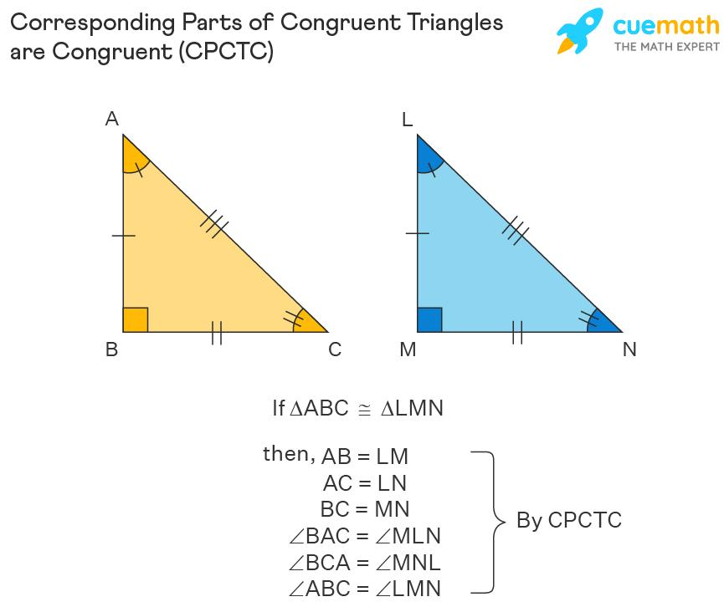
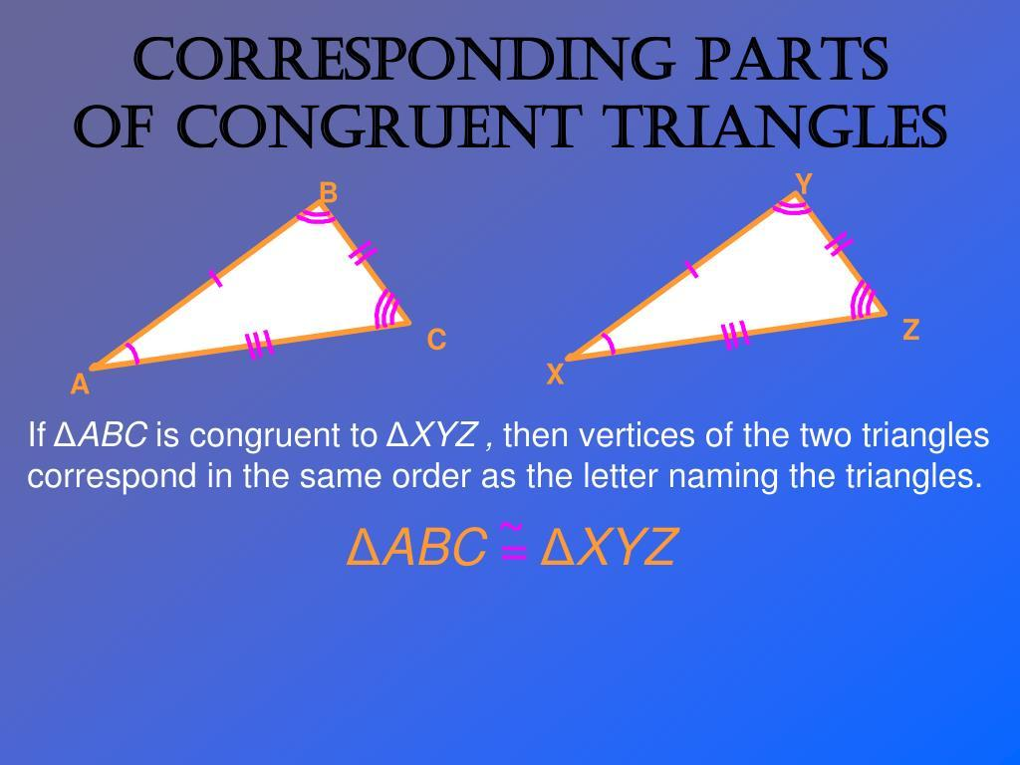
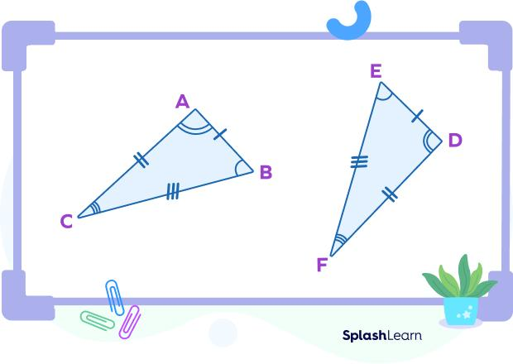
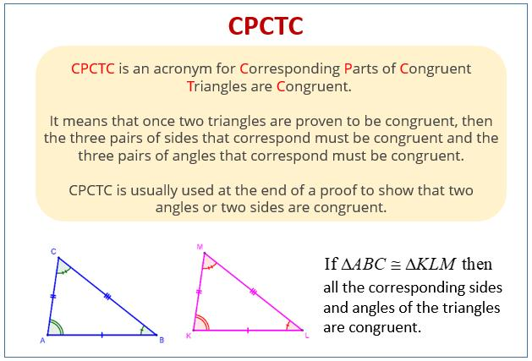

Example of a Congruence Proof
# Source: AI Source: Provided by: [Data Path: Persons Table -> ID Column: 1, Name_En Column: Motasem Essam] -> From: [ChatGPT] on [7/25/2026]
Suppose:
$$AB=DE \\ BC=EF$$
and:
$$AC=DF$$
We have three pairs of equal corresponding sides.
Therefore:
$$\boxed{△ABC≅△DEF}$$
by:
$$\boxed{\text{SSS}}$$
Then, by CPCTC:
$$\boxed{∠A=∠D}$$

Another Example
# Source: AI Source: Provided by: [Data Path: Persons Table -> ID Column: 1, Name_En Column: Motasem Essam] -> From: [ChatGPT] on [7/25/2026]
Suppose:
$$AB=DE \\ BC=EF$$
and:
$$∠B=∠E$$
The equal angle is between the two equal sides.
Therefore:
$$\boxed{△ABC≅△DEF}$$
by:
$$\boxed{\text{SAS}}$$

Congruence of Right Triangles
# Source: AI Source: Provided by: [Data Path: Persons Table -> ID Column: 1, Name_En Column: Motasem Essam] -> From: [ChatGPT] on [7/25/2026]
Right triangles have additional useful relationships.
For example, if two right triangles have:
- Equal hypotenuses.
- Equal corresponding legs.
then they are congruent by:
$$\boxed{\text{HL/RHS}}$$
This is especially useful when solving geometric problems involving:
- Heights
- Distances
- Buildings
- Bridges
- Surveying

Congruence in Coordinate Geometry
# Source: AI Source: Provided by: [Data Path: Persons Table -> ID Column: 1, Name_En Column: Motasem Essam] -> From: [ChatGPT] on [7/25/2026]
Congruence can also be tested using coordinates.
Suppose two triangles have vertices:
$$A\left(x_{1} , y_{1}\right), B\left(x_{2} , y_{2}\right), C\left(x_{3} , y_{3}\right)$$
The side lengths can be calculated using the distance formula:
$$\boxed{d=\sqrt{{\left(x_{2}-x_{1}\right)}^{2}+{\left(y_{2}-y_{1}\right)}^{2}}}$$
If all three corresponding side lengths are equal, the triangles are congruent by SSS.

Real-World Examples
# Source: AI Source: Provided by: [Data Path: Persons Table -> ID Column: 1, Name_En Column: Motasem Essam] -> From: [ChatGPT] on [7/25/2026]
Triangle congruence is useful in:
- Building construction.
- Bridge design.
- Roof construction.
- Structural engineering.
- Surveying.
- Architecture.
- CAD.
- Mechanical design.
- Land measurement.
- Computer graphics.
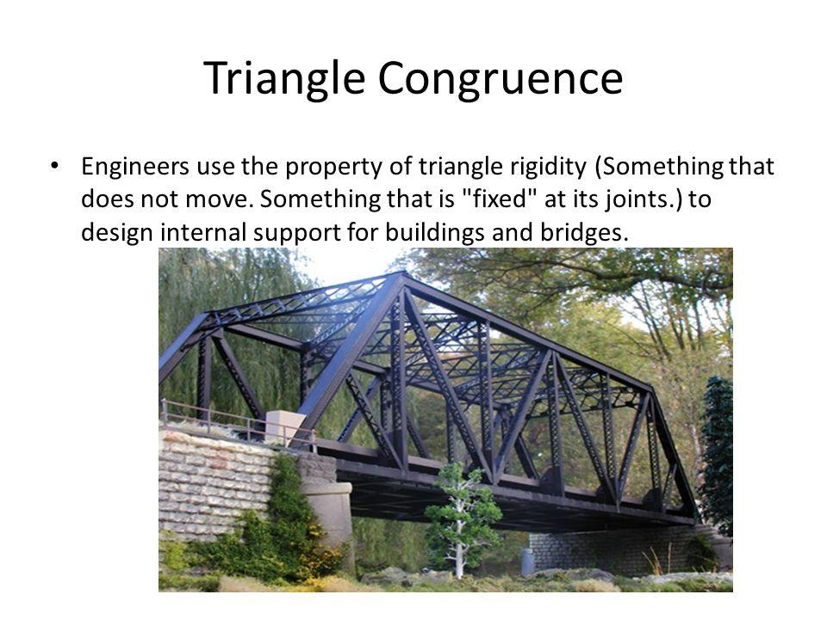
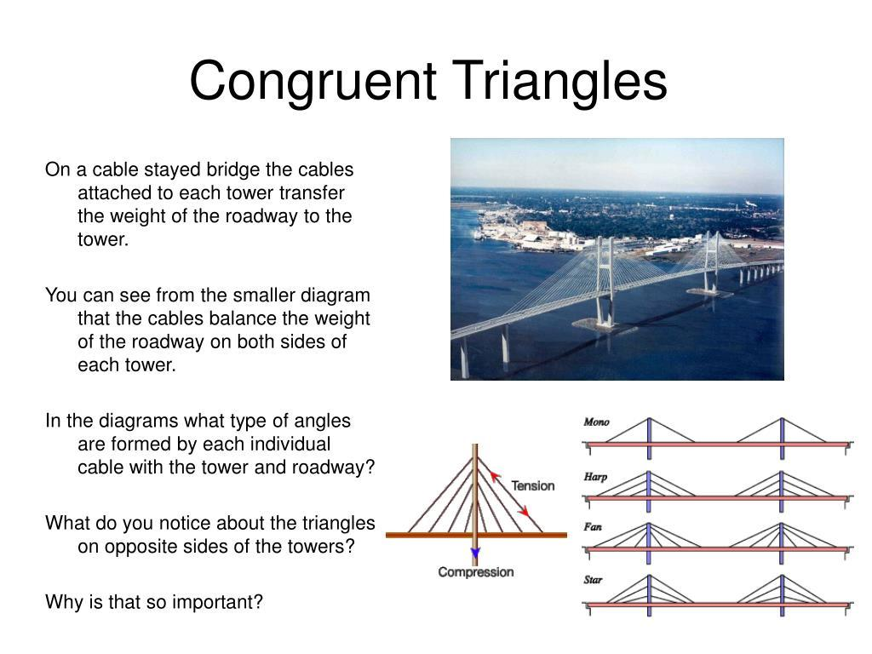
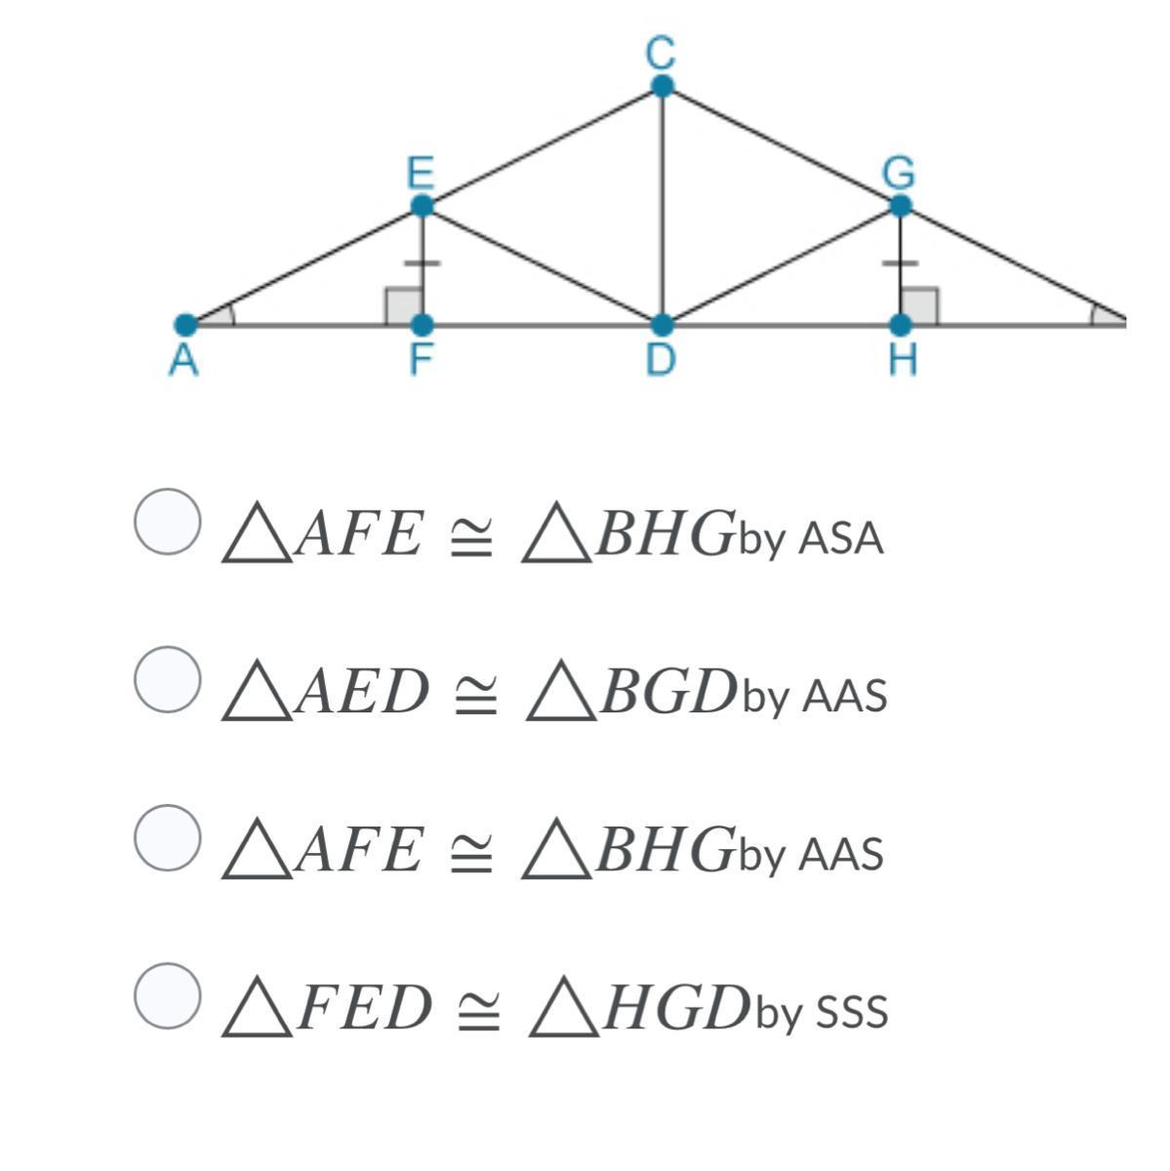
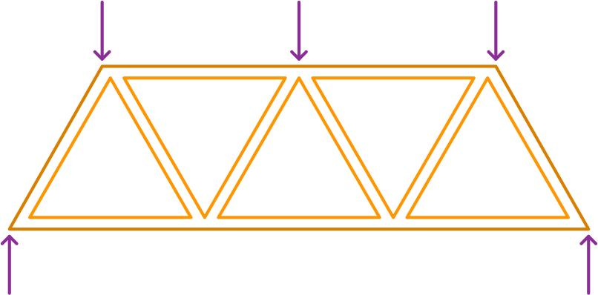
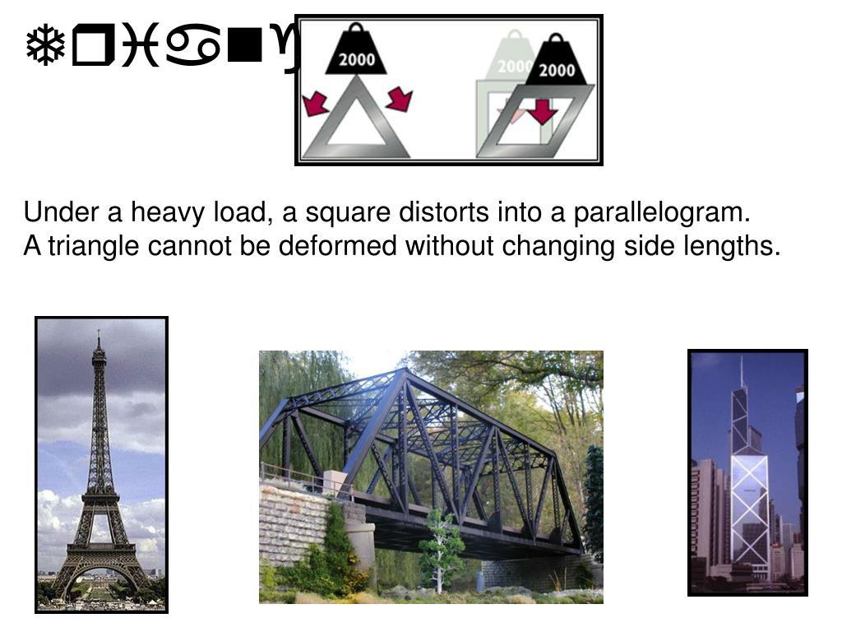
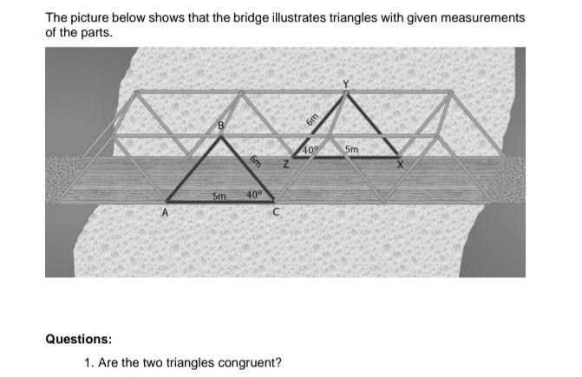

Applications
# Source: AI Source: Provided by: [Data Path: Persons Table -> ID Column: 1, Name_En Column: Motasem Essam] -> From: [ChatGPT] on [7/25/2026]
Triangle congruence is important in:
- Plane Geometry
- Euclidean Geometry
- Coordinate Geometry
- Trigonometry
- Engineering
- Architecture
- Surveying
- CAD
- Computer Graphics
- Structural Analysis

Advantages
# Source: AI Source: Provided by: [Data Path: Persons Table -> ID Column: 1, Name_En Column: Motasem Essam] -> From: [ChatGPT] on [7/25/2026]
Studying triangle congruence helps to:
- Prove geometric statements.
- Determine unknown lengths.
- Determine unknown angles.
- Establish equal areas.
- Analyze geometric constructions.
- Solve engineering problems.
- Understand rigid transformations.
- Build foundations for advanced geometry.

Limitations
# Source: AI Source: Provided by: [Data Path: Persons Table -> ID Column: 1, Name_En Column: Motasem Essam] -> From: [ChatGPT] on [7/25/2026]
Triangle congruence:
- Requires sufficient geometric information.
- Does not follow from AAA alone.
- Does not generally follow from SSA.
- Applies specifically to figures that have exactly the same size and shape.
- Must use correct correspondence between vertices, sides, and angles.

Comparison with Triangle Similarity
# Source: AI Source: Provided by: [Data Path: Persons Table -> ID Column: 1, Name_En Column: Motasem Essam] -> From: [ChatGPT] on [7/25/2026]
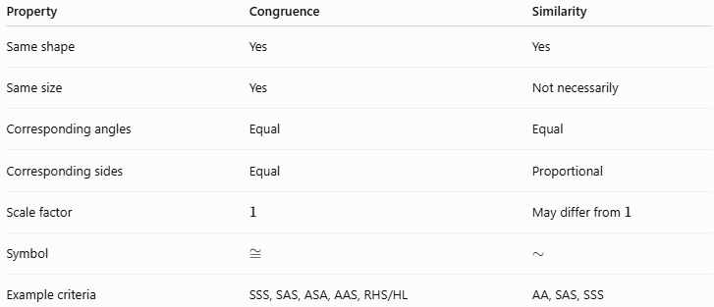
Property | Congruence | Similarity
Same shape | Yes | Yes
Same size | Yes | Not necessarily
Corresponding angles | Equal | Equal
Corresponding sides | Equal | Proportional
Scale factor | $$1$$ | May differ from $1$
Symbol | $$≅$$ | $$∼$$
Example criteria | SSS, SAS, ASA, AAS, RHS/HL | AA, SAS, SSS
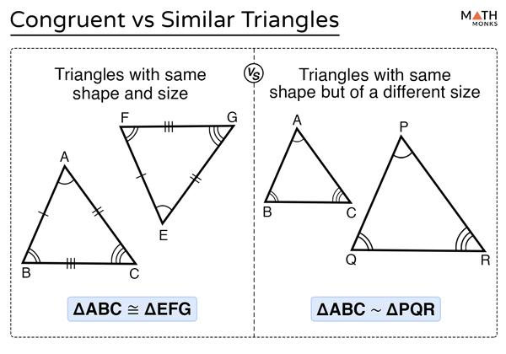
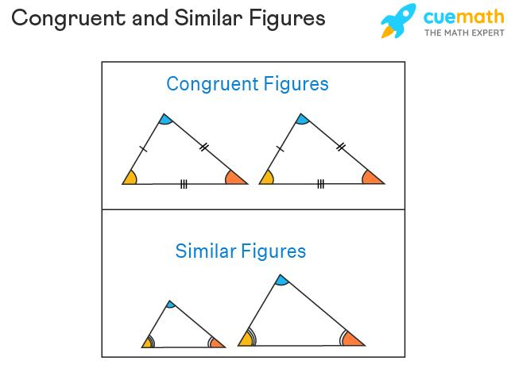
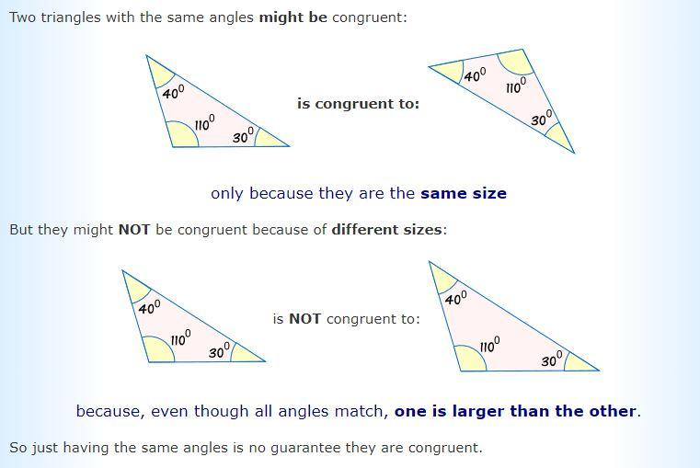

Key Points
# Source: AI Source: Provided by: [Data Path: Persons Table -> ID Column: 1, Name_En Column: Motasem Essam] -> From: [ChatGPT] on [7/25/2026]
- Triangle congruence means two triangles have exactly the same shape and size.
- The symbol is:
$$\boxed{≅}$$
- The major congruence criteria are:
$$\boxed{\text{SSS}} \\ \boxed{\text{SAS}} \\ \boxed{\text{ASA}} \\ \boxed{\text{AAS}} \\ \boxed{\text{RHS/HL}}$$
- AAA proves similarity, not congruence.
- SSA is generally not sufficient for congruence.
- Congruent triangles have equal:
  - Corresponding sides
  - Corresponding angles
  - Areas
  - Perimeters
- Rigid transformations preserve congruence.
- Dilation and shear generally do not preserve congruence.
- CPCTC can be used after proving two triangles congruent.

Conclusion
# Source: AI Source: Provided by: [Data Path: Persons Table -> ID Column: 1, Name_En Column: Motasem Essam] -> From: [ChatGPT] on [7/25/2026]
Triangle Congruence describes the relationship between two triangles that have exactly the same size and the same shape. When two triangles are congruent, every pair of corresponding sides has equal length and every pair of corresponding angles has equal measure.
The principal methods for proving triangle congruence are:
$$\boxed{\text{SSS, SAS, ASA, AAS, RHS/HL}}$$
These criteria provide efficient ways to establish congruence without having to compare every part of the triangles individually. Once congruence has been established, CPCTC allows corresponding sides and angles to be identified as congruent.
Triangle congruence is a fundamental concept in plane geometry and provides the foundation for geometric proofs, constructions, coordinate geometry, engineering, architecture, surveying, CAD, and structural analysis.

